St Matthews Big Local

stmatthewsbiglocal@gmail.com

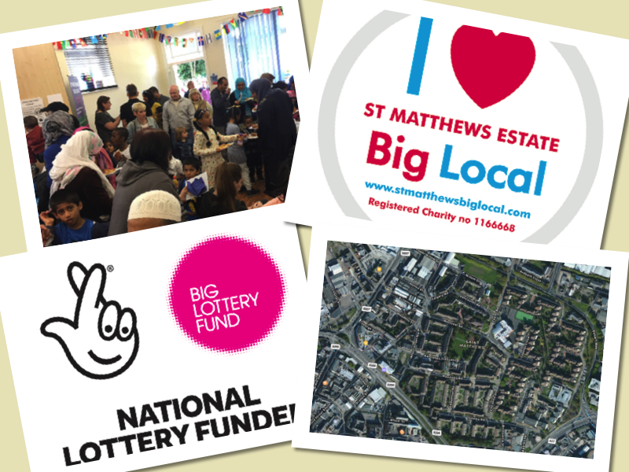

**ST MATTHEWS BIG LOCAL**

**The Second Plan (2017)**

Abstract

A detailed report of St Matthews and the work of St Matthews Big Local between 2015 and 2017, with a particular emphasis on the future.

Table of Contents

Chair’s Report 2

1. St Matthews Today 4

1.1. Standard of living: economy 5

1.2. Education and training of children, young people and adults 6

1.3. Crime levels 8

1.4. Population 12

1.5. Housing 14

1.6. Communal space 14

2. Background of St Matthews Big Local (SMBL) – Years 1 - 3 15

2.1. Priorities 16

2.2. What we have achieved so far – success stories 16

2.3. Additional funding 18

2.4. Strengths and weaknesses 19

3. SMBL Second Plan: Consulting for New Priorities – Years 4 - 6 27

3.1. Consultation - Research methods 27

3.2. Research findings 28

3.3. Strengths and weaknesses of findings 30

3.4. Priorities: What the community wants 30

3.5. What we want to achieve – Table of year 4 – 6 priorities 36

4. Method of Delivery – How we will deliver demand 41

4.1. Communication plan 41

4.2. Partnership working 42

4.3. Staff / Volunteering 42

4.4. Challenges and opportunities 42

5. Plan review 43

6. Expenditure – How much we need (table of expected expenditure) 44

7. References 45

8. Appendices 45

# Chair’s Report

Dear St Matthews’ community,

As Chair of St Matthews Big Local I am pleased to present to you the new three year Big Local Plan.

The first plan was deliberately aimed at projects providing immediate benefit and I am hugely proud of what we have achieved in the first three years.

We are a volunteer and resident led partnership board of 13 local residents and local workers. We have been delivering many projects and initiatives, which we will outline in more detail in this plan.

Many of these have started to make a real difference in St Matthews. We have been reaching around 3000 people each year. Most members of the community have benefited in some way.

Much of this would not have been possible without the many new partnerships we have formed along the way. We would like to thank all of those that have supported and helped us to deliver the St Matthews Big Local plan so far, and we look forward to building on this in the future.

Throughout the last three years we have continued to consult widely, and you continue to tell us that the vision that was set back in 2012 is still as relevant today as it was then.

We are pleased to see the vision becoming a reality and things changing for the better. The community has the opportunity to be together more, to create new friendships and strengthen existing ones. St Matthews is becoming greener, with more flowers, trees and allotments where people can grow together, sharing fruits and vegetables they have grown. Crime continues to fall, with around 341 less victims of crime since the start of Big Local. People have had more opportunities to increase their skills, learning and knowledge. They have gained new qualifications and some have gained employment.

Some of the most popular projects have been when the community has had the opportunity to get together; a Community Cinema, a community litter pick, basket planting, trips to the seaside, community parks day or our weekly women’s community cafe.

We still have seven years of Big Local funding available, with nearly £700,000 available, and we look forward to the opportunities this will bring. As we move forward we hope to bring a lasting legacy to St Matthews. We are also pleased that we have brought in additional extra funding of nearly £300,000 into St Matthews in just 31 months.

We have already taken several steps to future proof St Matthews Big Local by registering as a charity and acquiring a lease for St Matthews House, our new home and new community hub. These steps will enable us to move forward in a stronger position.

The new St Matthews Big Local plan will be adaptable. As the changing economic environment has seen services cut, we hope the plan will allow us to be more responsive to changes. We will continue to fund some of the more popular activities and continue to work hard delivering our vision with some new and exciting projects. We will look to deliver more legacy type projects.

We have been planning and working hard to install a Multi-Use Games Area in St Matthews. This will take up a significant proportion of the remaining grant, but we also hope to attract around £190,000 of additional funding to the project.

We are extremely pleased to have formed a partnership with the Cruyff Foundation, LCFC Community Trust and Samworth Brothers to deliver a world-class facility, which we hope the community will be proud of. We are now working with the local authority to seek the relevant permission to enable us to move forward as soon as possible.

We welcome anyone who lives or works in St Matthews to be part of this exciting journey, so if you feel you have something to offer and want to make a real difference, why not get involved?

Thank you for your continued support.

**Simon Johnson**

**Chair – St Matthews Big Local**

# St Matthews Today

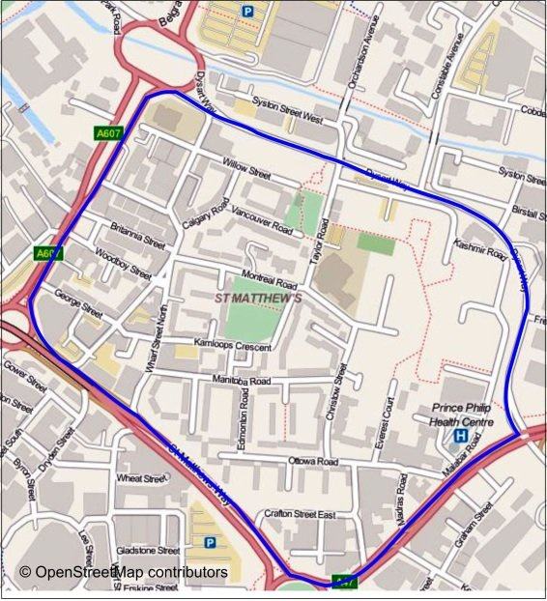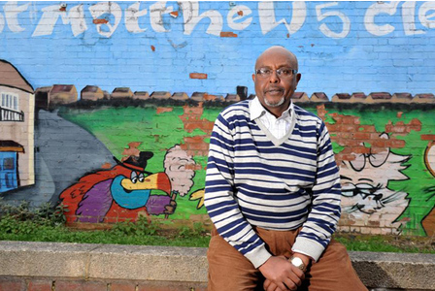

St Matthews is an estate within the inner city of Leicester in the East Midlands Region of England. The Estate which is named after the Anglican Church of St Matthews is known for its close proximity to the city centre. It comprises of a high number of housing units in a relatively small geographic area. The vast majority of the housing stock was built over half-a-century ago by the local council. Although the housing units are relatively new, the structural condition of many of the buildings is poor and the area is run down and in need of upgrading. This section will provide a brief introduction of St Matthews’ standard of living, education, crime levels, population, housing and communal space.

## Standard of living: economy

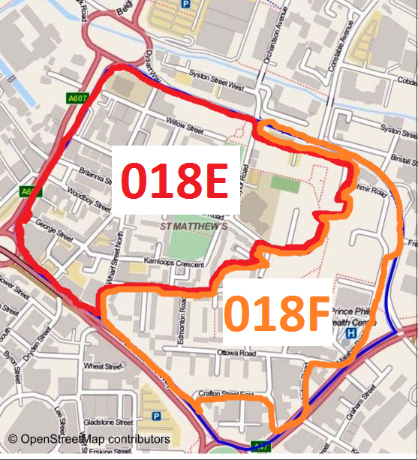St Matthews is amongst the most deprived neighbourhoods in England (reference 1). The indices of multiple deprivation cover 7 key areas: income; employment; health and disability; education; skills and training; barriers to housing and services; living environment; and crime. The area is divided into two sections called Lower Layer Super Output Areas, and they are distinguished as 018E and 018F (see right). There are minor differences between the two areas but they are both within either the 10% or 20% most deprived areas of the country in all categories.

For example, out of almost 33,000 neighbourhoods in England,

* 018E is ranked 408th whilst 018F is ranked 837th in terms of income deprivation.
* 018E is ranked 1,470th whilst 018F is ranked 1,995 worst in the country.
* Importantly, in terms of income deprivation affecting children, 018E is ranked as 2,577th and 018E is ranked at 4,173 worst in the country.
* Strikingly, in terms of income deprivation affecting older people, 018E is ranked 71st worst in the country whilst the 018F is 44th.

The most recent 2015 official figures have revealed that the area is the most deprived in Leicestershire, and amongst the 10% of most deprived neighbourhoods in England (reference 1). The standard of living in St Matthews worsened over the last 15 years, as the original St Matthews Local Plan (reference 2) and the Indices of Deprivation of 2007 and 2011 has shown. In 2014 the number of children under 5 living in Income Deprived Families was 82.5% for St Matthews, in contrast to the Leicester average of 33.8%. Furthermore, St Matthews has the highest percentage of children 0-18 living in workless households at 42.3% (Leicester average 25.3%).

## Education and training of children, young people and adults

One of the poorest groups in Leicester, by a wide margin, is the Somalis who live in St Matthews Estate. Their unique economic and educational status has received special interest from The Economist (reference 3). Refugees and asylum seekers from civil war, who often passed through Sweden, the Netherlands or Denmark, have ended up in Leicester in the hope of a better life. They are most affected by unemployment, which, on St Matthews, was three times the national average at the last census. Studies have shown that poor children will not achieve as much academically as their better off counterparts. This is not necessarily the case in St Matthews, however.

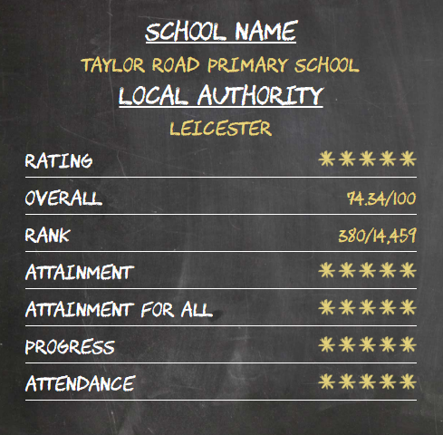At the heart of St Matthews is Taylor Road Primary School which is amongst the best performing schools in Leicester in standardised tests (reference 3). The headmaster, Chris Hassall, credits the residents who channel their ambitions through their children, who believe that education is their way out of poverty and social disadvantage. The parents/carers insist that their children turn up for extra lessons at evening and weekends. The children from the large Muslim community also attend a Madrassa every day after school. The importance of education and attendance is widely understood by the residents of St Matthews, and this is reflected in Taylor Road Primary School’s attendance figures: this year’s school attendance is 96% (reference 4). The school has undergone serious refurbishment over the past years to accommodate more pupils, and currently there are approximately 740 students at Taylor Road School. By far the majority of pupils have English as an additional language, with over 35 languages being spoken in the school. Taylor Road School, which is one of the prides of St Matthews, has consistently been rated as ‘outstanding’, and achieved a large number of awards. Without question, Mr Chris Hassall, the head teacher, who received a National Leader Award, plays a key role in the school’s success. At national level, Taylor Road School has been rated 380th out of 14,459 schools in the country, and has an overall score of 74, 34%, according to the Real Schools Guide 2007. The school is ranked as the first best in Leicestershire.

There isn’t a Secondary School on the Estate so the young people access a number of secondary schools across Leicester. The largest numbers go to Soar Valley Community College, Moat College and Rushey Mead School. In terms of performance, Soar Valley and Rushey Mead School have been rated by OFSTED (reference 5) as ‘Outstanding’ whilst Moat Community College is ranked as ‘Good’. More sporadic numbers attend Babington, Sir Jonathon North and Fullhurst Community College. It is not clear what grades the young people of St Matthews achieve at these secondary schools, but on the whole at least 60% of students from these colleges achieve 5+ A-Cs (includes English, Maths and Science).

Additional provision for children and young people is provided by the What Cabin (pre-school, after school and holiday provision for the 0-13 age range) and the Children, Young People and Family Centre (CYPFC), both on Vancouver Road. The latter provides a range of services that support parents and carers to give their child the best start in life. The What Cabin, on the other hand, is a registered charity run by St Matthew's Children's Action Group operating from a single-storey building on a public park in the St Matthew's area. It has 200 children registered between the ages of 5 and 11. There are also several nurseries and pre-schools but very few childminders because of the lack of suitable and large enough homes.

Youth provision on the Estate is poor and has declined in recent years. The youth club is facing financial difficulties due to funding cuts and may face closure, similar to the Contact Project which had to close its doors after 15 years of service. The Contact Project which was also the Locally Trusted Organisation of St Matthews Big Local (SMBL) used to deliver group work and mentoring support to children and young people.

The adult population are at a disadvantage in terms of Education, Skills and Training. The government’s Indices of Deprivation data of 2015 (reference 1) has found that the two St Matthews neighbourhoods (018E and 018F) are 2,243rd and 2,056th respectively out of 32,844 neighbourhoods in regards to adults’ education, making St Matthews amongst the 10% most deprived neighbourhood in the country. It is understood that along with economic disadvantage, language and other social disadvantages contribute to this situation. Leicester Adult Skills and Learning Service (LASALS) which operates from St Matthews has indicated that from October to December 2016, 33 course enrolments were made from 16 adults from St Matthews, taking part courses that range from Cake Decorating to Food Safety and from First Aid to Local Photography. With the help of SMBL, the uptake of paid courses has increased significantly from 17 residents supported in 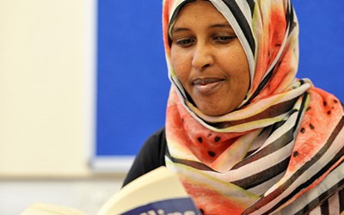2014/2015 to 45 in 2015/2016. A total of 69 St Matthews residents were in receipt of free courses (such as ESOL) because of their eligibility. Furthermore, SMBL’s survey of 2016 which measured residents’ perception of priorities indicated that the community is open and interested in a wide range of training/educational programmes. For example, 52% of residents felt that the community would benefit from parenting classes, 67% from personal financial awareness, 61% from preventative diseases classes and 62% from nutrition and fitness training. The partnership board will be looking at ways of delivering the most demanded training/educational programmes to the community with the fund from Big Local.

## Crime levels

By the late 20th century the area was notorious for petty crime, drug dealing and prostitution that centred on the two large tower blocks in the area of the Estate known as Arnold Street, which were demolished in 2000. St Matthews was known as `Sitex city` with empty properties being susceptible to vandalism. It was a transient area with lots of people moving in and out with a small settled community. The accommodation was ideally suited to small families and lone individuals and those with large families had to move away as the properties were too small. As part of the government Estate Action programme in 1990s, to help alleviate the problem de-topping of the top floor of blocks of flats occurred in particular areas of the Estate was carried out. This resulted in a limited number of larger 4 bedroom properties enabling families to stay and build roots rather than move. The social problems of the times were not helped by the open plan nature of the area which allowed people from neighbouring areas surrounding the Estate to come easily onto the Estate to partake in crime or antisocial behaviour and prevented them getting caught as escape was easy. According to long standing residents the majority of trouble was caused by outsiders not locals living here. These issues such as burglaries and joyriding have stigmatised the area and its people to this day. The local police team speak of dealing with over 400 burglaries a year at that time.

Crime across the Leicestershire Police area has risen slowly since 2015. Leicestershire Police Federation, which represents rank and file officers, said that years of budget cuts were taking their toll, resulting in rising crime and stress levels and workloads for officers.

Leicestershire Police currently have around 1,800 officers, whereas at its height in 2009 it had 2,300.

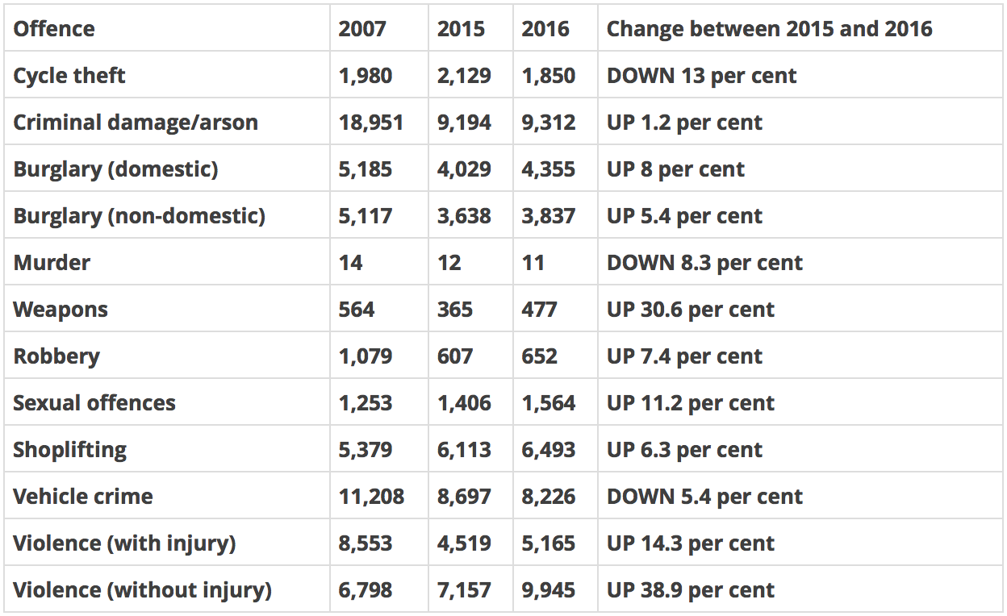

(Reference 6)

St Matthews policing data is normally included in the ward boundary so data collection is made slightly more complicated however, data from Police.co.uk shows that for the 36 months prior to the introduction of St Matthew’s Big Local there were 1257 recorded crimes, compared with 851 recorded crimes for the 31 month period since the St Matthew’s Big Local delivery began.

Prior to Big Local there were 34.8 crimes a month on average.

Since Big Local there are 23.6 crimes a month on average.

This represents 341 less victim of crime, more than the whole reported crime for 2015. This success cannot be put down to one single event, agency or organisation but the team work, unique demographic and community spirit and resilience shown in St Matthew’s. Whatever the reason for the reduction it helps to achieve our vision of a St Matthews which is safer and more secure.

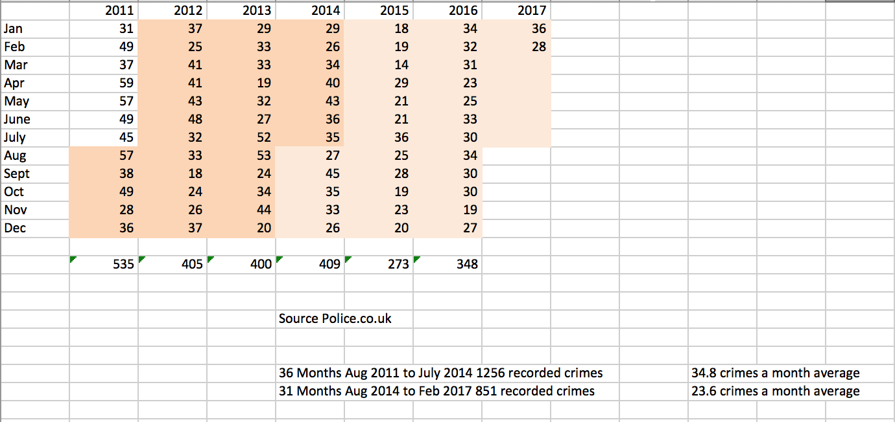

From March 2016 to February 2017 there were 346 recorded crimes in the St Matthew’s. Crime types are difficult to identify for St Matthews only as the data collected is based on Wycliffe ward boundaries. However the graph below will indicate which crimes are more prevalent in the area with Anti-social behaviour at 78 (22.54%) followed by Violent and Sexual offences 76 (21.97%) and Criminal Damage and Arson 57 (16.47%).

Police recorded crime is not currently considered a completely reliable measure of trends in crime for most crime types, since it is prone to changes in recording practices as well as changing behaviour in public reporting of crime. For example, it does not include crimes that do not come to the attention of the police or are not recorded by them. As a result, the actual crime trends in St Matthews might be higher than the figures below. From the data that is available from the local police, it is known that only 8.96% crimes lead to the prosecution of the offender in St Matthews, whether the offender sent to the court or dealt with by the police. The police could not act further in 76.12% of cases, largely because they could not identify the suspect or unable to prosecute due to insufficient evidence.

**Comparison of crime types in this area   
between March 2016 and February 2017**

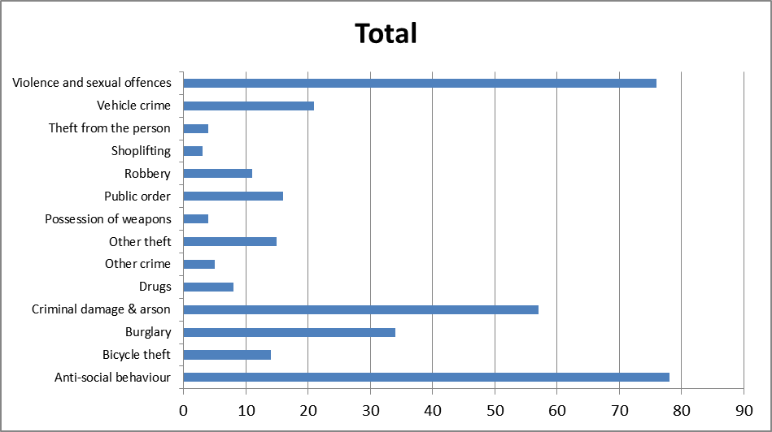

|  |  |  |
| --- | --- | --- |
| **Crime Type** | **Total** | **Percent** |
| Anti-social behaviour | 78 | 23% |
| Bicycle theft | 14 | 4% |
| Burglary | 34 | 10% |
| Criminal damage & arson | 57 | 16% |
| Drugs | 8 | 2% |
| Other crime | 5 | 1% |
| Other theft | 15 | 4% |
| Possession of weapons | 4 | 1% |
| Public order | 16 | 5% |
| Robbery | 11 | 3% |
| Shoplifting | 3 | 1% |
| Theft from the person | 4 | 1% |
| Vehicle crime | 21 | 6% |
| Violence and sexual offences | 76 | 22% |

It is assumed that closer police-public engagement would help fight crime more effectively since the public can be the extension of the ‘eyes and ears’ of the police. The coalition government's White Paper on police reform acknowledged that the police's success in fighting crime is based on a wide range of partners, the public being the most important one (reference 7). Citizens are significantly more likely to act as the ‘eyes and ears’ of the police if they have trust, faith and confidence. If the positive relationship for one reason or another is withdrawn the police would be 'powerless' over the most transparent illegality in our streets because the 'power of our police is almost entirely derived from co-operation given to them by the public' (reference 8).

Frankly, the local policing team in St Matthews holds a very positive relationship with the community. The team, which consists of two Police Officers and two Police Community Support Officers, Is based locally in the estate within the local health centre – Prince Phillip House. The combined service of the officers is over 59 years, with 33 years of their service based within St Matthews.

The team members are an established and integral part of the community. This was highlighted recently when one of the respected Police Officers PC Austin Jackson passed away suddenly; many of the local community signed a book of condolences, sent messages of sadness to the officer’s family and attended his funeral service at Leicester Cathedral.

The longest serving member of the team PC Varney was recently recognised in the New Year’s honours for his dedication to the community and was awarded a (BEM) British Empire Medal (reference 9). In 2014, PCSO Nicky Whitehead won the title of Police Community Support Officer of the year with Jean Williams, chair of the Estate's Tenants' and Residents Association, saying: "Nicky is brilliant at what he does."

The team start their tour of duty on the Estate each day and attend numerous community engagement events throughout the year either organised by the team or other agencies.

A small budget of £200 has been provided to the team from Big Local funding to help support continued engagement events, this budget has been underspent each year but has helped the team to organise innovative event such as ‘Coffee with a Cop’, ‘Breakfast with the Bill’ and many other small initiatives, some of the events have attracted around 80 interactions with the community.

Many of the officers also take up voluntary duties on the Estate and can often be seen around the community on their days off undertaking roles such as school governors or trustees of local charities. In fact, the Chair of SMBL is PCSO Simon Johnson, who has proved to be absolutely invaluable in terms of the amount of work he does (much in his own time) and his energy and commitment in getting SMBL to where it is today.

## Population

Today the population of St Matthews is one of the most diverse in Leicester. The largest cultural groups are Black African, Asian and White British. The Estate has large numbers of new arrivals and is home to Portuguese, Polish, Romanian, Caribbean notably Montserratian, Zimbabwean, Somali, Indian, Pakistani, Kurdish, French, Chinese and Irish residents amongst others. Although the Estate faces some significant challenges, local residents participating in the Big Local initial consultations indicated that they felt some pride in the Estate and that it had improved substantially in recent years. St Matthews has a strong entrepreneurial spirit and local people have developed several voluntary and community sector projects and organisations in the past ten years or so to meet the specific cultural and social needs within our wide ranging demographic profile.

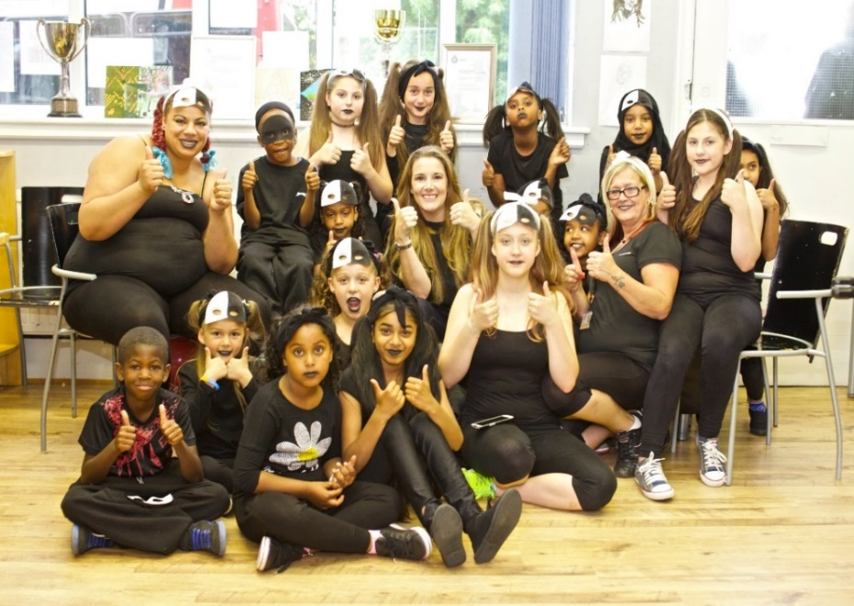Overall, It is a young Estate in terms of cultural change and the large population of children being born and raised here as the first or second generation of the newly arrived communities. The total population (reference 1) is 4241 of which   
48% are aged under 24   
16% aged 0 - 4%,   
23% aged 5 – 15 and   
9% aged 16 – 24  
22% aged 30-44.   
For the 0-19 age range,   
25% are from Asian families, 58% from Black families,   
3% White European families and 12% from various Dual Heritage backgrounds.

St Matthews holds many key amenities: Taylor Road Primary School, St Matthews Centre (until late 2013 officially known as St Matthews Neighbourhood Centre but better known among younger community as the Sports Hall), a local housing office, a local library and the Tenants and Residents Association, chaired by the area’s most well-known community advocate Jean Williams MBE. Businesses include a pharmacy, a Post Office, a halal butcher, barbers, a petrol station, cafes, clothes stores, factories, takeaways, garages, shops and small supermarkets. Two new cycle shops have also recently opened on the Estate. Some disused factories have been converted to mosques and Islamic cultural centres. Prince Phillip House contains the NHS medical centre for the area, which was opened in 1996 after lobbying by area GP Dr Lennox. The area has become a beacon for the East and Central African Muslim communities, particularly from Tanzania and Somalia, with stores, places of worship and recreational facilities enabling cultural expression and life to thrive. The most common misconception found outside the Estate is that ‘only Somalis’ live there. The area was targeted by the second EDL demonstration in Leicester in February 2012. It was protected by a large police presence, supported by community leaders and workers, which prevented major disturbance.

## Housing

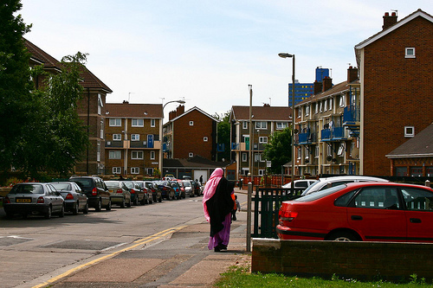Housing is a major issue on the Estate with it being one of the most sought after areas in regard to housing allocation in opposition to its position in the late 20th century. The majority of Council tenancy presently is taken up by all Asian at 28.15%,   
all Black at 23.31%,   
all White at 12.78% and   
all not known 29.91%.   
The majority of the housing stock remains predominantly two bedroom maisonettes with limited 3+ bedroom units available. This has created overcrowded conditions for many growing families. There is a virtual waiting list for the Estate estimated to be over 30 years. Housing for larger families is a significant need not only here but across the Spinney Hills Ward. As the population grows younger and families continue to grow then space will continue to be an issue and overcrowding will become the norm across the Estate. The design of the blocks and the heating system has led to long standing issues with rat infestation, rubbish collection, littering and fly tipping.

## Communal space

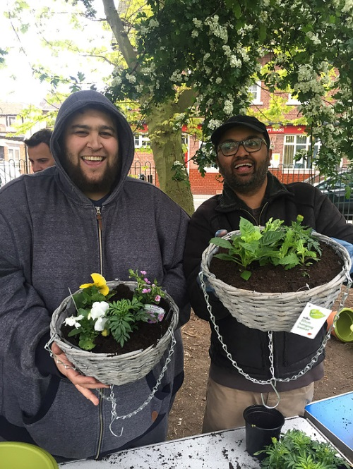St Matthews is compact and less than 20% of the area is dedicated to open and green space for families and children to socialise and exercise. There are two small well-used parks but these suffer from a lack of investment and maintenance as council budgets and resources shrink. Many of the blocks have small communal courtyards and there is a small grassed area at the edge of the Estate which has an ongoing problem with it being used for prostitution. In these spaces animals and residents converge and the area’s cleanliness is poor with dog mess and rubbish affecting how people can interact with it. Play equipment breaks down through heavy use and a lack of regular maintenance. There are regular reports of anti-social behaviour in communal open spaces within blocks of housing where children are playing because they have nowhere else to go or parents will not allow them to go to further away larger parks for safety concerns. Due to the limited parking spaces on the Estate, unused areas have been sought over the recent years to turn them into car parking bays. For example, on Manitoba Road and Ontario Close, more than five corner green plots were converted into parking bays. These plots had overgrown shrubs and serious litter issues. St Matthews Tenants and Residents Association, on the other hand, turned two plots of land into allotments which several residents are using to grow vegetables and plants. This was made possible with the funding grant available from St Matthews Big Local. There is a large, mostly unused grassed area on Willow Street that is the proposed site for the MUGA. Recently the Local Authority has installed an outdoor gym there which is already proving popular.

# 2. Background of St Matthews Big Local (SMBL) – Years 1 - 3

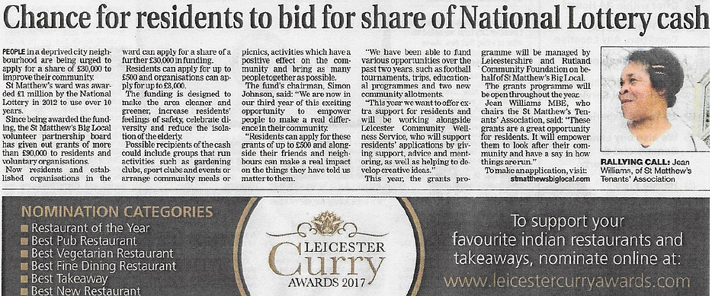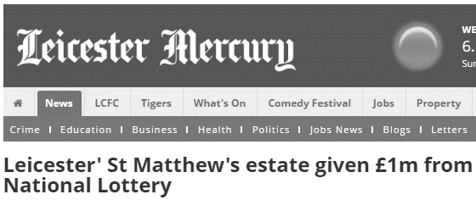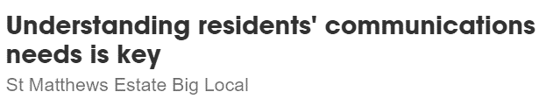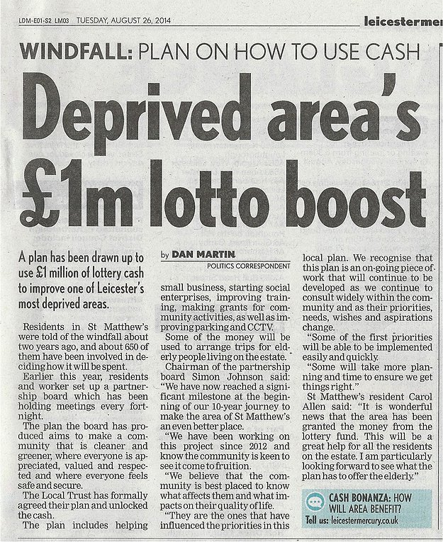

Following the announcement that St Matthews was a Big Local area in February 2012, many meetings were held with interested residents, agencies and voluntary groups gradually coming together to form a Steering Group. The Steering Group pulled together the ideas and suggestions made by everyone who took part to prepare the vision and project ideas for the first three year Plan. This was consulted on widely at St Matthews Community Parks Day, on the street and other outreach activities. An ideal person specification for Partnership Board members was developed by the Steering group and local people were invited to apply to become members of the partnership Board. SMBL Leicester (SMBLL) became a CIO on 21st April 2016 after operating for 2 years as an unincorporated organisation (See Appendix A – SMBL Constitution).

In October 2016 we took over the ground floor of St Matthews House (a building previously occupied by the Contact Project) which we hope to develop into a community hub. These changes meant a lot of extra work for the Board members in terms of drafting and approving a range of policies (reference 10) and getting the building refurbished and ready for use, which is still a work in progress.

## Priorities

The priorities for years 1 to 3 were identified in early 2013 through a number of consultation events across the Estate with different interest groups. Residents, young and old, were asked their opinion on the Estate and asked what they saw as priorities in terms of helping the area improve and how we should use one million pounds over the next 10 years.

By the summer of 2013, the steering group membership had collated the various suggestions and grouped them by theme. These subsequently became the vision that formed the aims of our Local Plan. They are to make St Matthews a place:

1. which is cleaner and greener
2. where everyone is appreciated, valued and respected
3. where everyone can reach their potential and local businesses flourish
4. where everyone feels safe and secure
5. where we can celebrate diversity, talent and creativity

## What we have achieved so far – success stories

Over the past few years, a lot of work has gone to ensure that the above aims are met. For example, Big Local has made a real difference to people’s lives; it has given people new skills and opportunities. The grants programme alone has encouraged St Matthews’ organisations to start working together to deliver projects. Some of these organisations have developed formal partnership arrangements. The funds have promoted a sense of cohesion in the Estate with organisations and individuals working together who previously had not. The grants programme has, moreover, given residents a real opportunity to become empowered to make a real difference in St Matthews. It is estimated that thousands of members of the community have felt the positive effect of the grants programme to 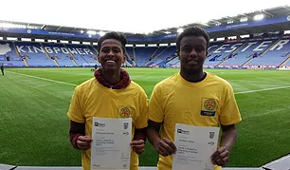date. As well as supporting residents, SMBL has also been supporting the business community within St Matthews by working with Spring to Action where local residents with a start-up idea got advice and support to make their dreams become a reality, and existing businesses could get help and advice to look at improving their business. Furthermore, new and existing businesses now have the opportunity to apply for loan funding to support them further through MCF Loans. This initiative was set up to make loans to financially excluded individuals and businesses that could not access affordable credit from mainstream banks and building societies. A key aim was to reduce the burden of debt and high interest charges faced by low income households and provide an alternative source of credit to the cheque cashers, high cost door-step providers and illegal money lenders.

One of our greatest successes has been our partnership with LASALS and CYPFC to provide funded training opportunities for residents. Since taking over the lease of St Matthews House we have been able to use it to deliver training courses.

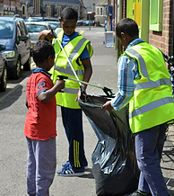In addition to the above, SMBL arranged a number of community trips to various attractions which were very popular, benefiting hundreds of residents from all ages. The venues included Cadbury World, Skegness, Twinlakes Park and Rutland Water. Specifically for young people, SMBL managed a cycling event which saw over 100 residents taking home free bike safety and security equipment as well as participating in an educational workshop. The elderly residents, on the other hand, were involved in regular trips and dinner events to reduce the levels of social isolation that they often experienced. The community members were also very happy to see that fundamental work was targeting the senior citizens of the community. For example, one social media user wrote ‘*So proud to see* *this*’, whilst another wrote ‘*what an excellent event; nice to see communities sharing a festive meal together’.* Furthermore, one went on to say that this was the *‘best thing that has happened in St Matthews’.* Amongst the other popular activities is the St Matthews Clean Up, which again saw over 100 volunteers participating. Over the two events, more than 100 black bags of rubbish were collected, raising community awareness about littering.

All of the activities have had a massive impact on the sense of community and have succeeded in promoting community cohesion. Simon Johnson Chair of St Matthews Big local said:

*‘At a recent trip to Twinlakes Park it was great to see families coming together - some of the community sat together at lunchtime to share their food and started to create new friendships. Many of the community don’t get the opportunity on a day to day basis to meet with their neighbours but the trips we organise are a great opportunity to develop new friendships.  The evaluation which was completed by 67 people, 61 of those people indicated yes when asked, ‘Did you have the opportunity to meet new people?’ Comments from a local resident also said, ‘The best thing about the trip was the opportunity to get together with people from the community’.’*

## Additional funding

The Board, particularly the Chair, have been very proactive and successful in applying for and being awarded additional funding and donations whether in cash or kind, which is essential if SMBL is to continue to operate beyond the initial 10 years. The table below details the funding we have or hope to be awarded so far:

|  |  |
| --- | --- |
| **Funding** | **Amount £** |
| Customers of Bargain Booze (Charity boxes) | 400 |
| Contact Project | 1,403 |
| Private donation | 30 |
| Taylor Road School (for Parks Day) | 600 |
| National Lottery - celebration grant | 6,410 |
| British Heart Foundation: 2 x defibrillators, defibrillator housing and training resources | 4,500 |
| Howdens: kitchen donation | 6,000 |
| LCC Get Growing grant | 425 |
| Two LCC Cycling grants | 600 |
| LCC Outdoor Gym - £28,000 - awarded (£2,800 contribution by SM Big Local) | 25,200 |
| LCC walkway improvement to neighbourhood centre, including new lighting, decorating and power washing if floor: (£2,500 estimated). | 2,500 |
| Leicester Ageing together decorating support | 400 |
| Leicester Ageing together Christmas meal | 300 |
| Cruyff foundation contribution toward MUGA | 50,000 |
| Samworth Brothers contribution towards MUGA running costs | 40,000 |
| **TOTAL AWARDED** | **138,768** |
| *Sports England MUGA funding application - £100,000 awaiting decision* | *100,000* |
| *Tudor Trust Community Hub costs application - £40,000 awaiting decision* | *40,000* |
| *LCC Wycliffe Ward for Christmas meal application- £475 awaiting decision* | *475* |
| ***TOTAL PENDING*** | ***140,475*** |
| **TOTAL ADDITIONAL FUNDING** | **£279,243** |

## Strengths and weaknesses

The partnership has been involved in dozens of activities and programmes over the past three years in an effort to implement the promised priorities. As expected, all these activities came with challenges but in the majority of cases these challenges were reduced to a minimum due to the pro-activeness and good planning skills of the partnership team. The strategy of SMBL was to work with all agencies of St Matthews and with as many residents as possible, in an effort to utilise the community’s passion, skills and strengths to reach a mutual goal: to improve the social, physical and economic state of St Matthews. It was recognised that the vision would not be met by solo-working, and hence multi-agency partnerships would be valuable in many contexts. Some very strong partnerships have been developed, especially with the Police, LASALS and the Community Wellness Service (unfortunately no longer operating). It is hoped that we can further develop and strengthen partnerships in the coming years. For this reason, most of the priorities were implemented easily and quickly as there was more potential for productivity/efficiency, there was greater support and diversity, and sharing of responsibilities and resources. For instance, in our efforts to reduce anti-social behaviour in St Matthews, we commissioned the Contact Project to deliver outreach work to young people who were causing a nuisance. With the closure of the Contact Project we diverted unused resources to Soft Touch Arts and the LCFC community team to deliver a 4-week football project. We have funded dance sessions and a summer school run by local community groups and have supported an Awards ceremony for the autumn. All of the above work in reducing anti-social behaviour by keeping young people occupied was only possible through Multi-Agency Partnership, our staffing resources being limited because all partnership members are volunteers. Working in partnership with other agencies not only provides the expertise of their staff but it can also release their own resources without having to spend Big Local money in order to make things happen.

Some of the activities, on the other hand, took longer than expected, ironically again due to partnership working. This was because other partnering agencies/individuals did not have the same amount of planning, flexibility, energy and commitment as SMBL. For example, a partnership with Leicester Riders Basketball Club to provide 10 sessions for 20 people has fizzled out with poor liaison by the Club. Another example is in relation to the outdoor gym that we wanted to have in St Matthews in an effort to ‘subsidise entry to local sports and fitness centres’. Almost two years ago, the Chair of SMBL responded to a tweet from the Deputy Mayor about outdoor gyms and asked if St Matthews could have one. This led to an agreement that Big Local would put 10% towards to cost of an outdoor gym in the area. It took longer than expected for the site to be agreed so although it was hoped the gym would be ready by August 2016, it was finally installed it in February 2017.

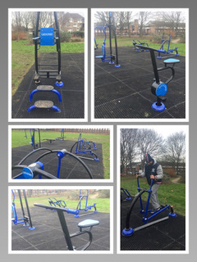

* 1. **What we have achieved so far - table**

The original plan set out a range of outcomes and measures, detailing what we aimed to achieve from year 1 to year 5. In the following pages is a more detailed review of what we have achieved in years 1 - 3.

|  |  |
| --- | --- |
| ***We want St Matthews to be a place which is cleaner and greener. (environment & open space)*** | |
| ***Objectives (what we said we’d do...)*** | ***Outcomes (what we have and have not achieved so far...)*** |
| *Educate everyone about litter & dumping*  *rubbish to control pests* | * *Successful St Matthews Clean Up days* * *Recycling bins introduced that increased recycling* * *School poster competition and assemblies* * *Education and information events* * *Supported Leicester City Council in the promotion of the ‘I Love Leicester’ app* |
| *Start a Parking Working Group* | * *Parking strategy taken on by the Tenants Association with our support* |
| *Start a community energy bulk buy scheme* | * *This was a Year 5 priority so it hasn’t been included in any consultation and has not yet been undertaken* |
| *Community car share* | * *A car share working group has been set up* |
| *More benches to sit on* | * *4 benches were supplied in different places* |
| *More litter bins on the streets* | * *A mapping exercise was completed which established that there were plenty of bins located across the Estate, particularly in courtyards. Public areas were identified with few bins and a so a further 5 bins (1 supplied by the Council who are emptying and maintaining all the bins) installed* |
| *Additional things we achieved over and above the original plans (which have either been directly funded, or funded by SMBL grants and other organisations to local groups and individuals)* | * *2 new allotments with 21 beds were funded via grants programme* * *2 get growing events organised with 30 people attending the 1st event and 120 at the second event.* * *Funding for new hanging baskets given to the Tenants Association* * *Local resident and Big Local, supported by 15 Volunteers from Asda completed additional planting near to the community hub and local shop. Including 12 fruit trees* * *Local charity supported to invest a grant of around £8,000 into St Matthews by planting corner plots, new fencing and raised flower beds* |

|  |  |
| --- | --- |
| ***We want St Matthews to be a place where everyone is appreciated, valued & respected (young people, children, families & elderly)*** | |
| ***Objectives (what we said we’d do...)*** | ***Outcomes (what we have and have not achieved so far...)*** |
| *Develop Inter-cultural & Inter-generational activities* | * *A range of trips and visits* * *Celebrations and local events* * *Weekly women’s community café* * *Parks week / parks day since 2012* * *Get growing scheme – visited by over 150 in two years* * *History of Somalia book produced and distributed* * *The awards ceremony didn’t happen but we did present certificates at the AGM* |
| *Improve access to community facilities* | * *Outdoor gym – supplied in partnership with Leicester City Council with free access to all* * *MUGA* * *St Matthews House Community Hub – training, meeting space and community development opportunities* * *Sports Hall discount for local groups (50% off room hire costs at St Matthews Centre)* * *Grant funding to allow improved access to training (in partnership with LASALS)* * *Subsidised entry to ‘Where the River Runs’ dance and drama project* * *2 x community cinema showings at the neighbourhood centre* * *Free and reduced tickets to the local cinema* |
| *Provide positive activities for all ages (which have either been directly funded, or funded by SMBL grants programme and other organisations to local groups and individuals)* | * *LCFC Kicks programme* * *Riders basketball* * *St Matthews Dynamos* * *IQRA Football Club* * *Monthly long bike rides around Leicester* * *11 weeks of street based activities (delivered by Soft Touch Arts)* * *16 weeks of informal education activities including art, cooking and team games (delivered by the Contact Project)* * *Weekly basketball sessions (delivered by Rajo)* * *Empowerment project with Eva Organisation for Women and Charnwood Learning* * *Mini World Cup – Eritrean, Sudanese and Somali community partnership event* * *Outdoor Pursuits Centre activities* * *Dance sessions* * *Grants programme established* |
| *Encourage an elders working group* | *Formal working group not established but consultation completed on activities they wish to happening and included:*   * *Elders lunch club* * *Community Cinema old film at church court* * *Pub lunch for elderly* * *Afternoon tea for the elderly* * *Elders Christmas Meal organised* |
| *Provide seats at bus stops & around the Estate* | * *4 new additional seats were placed at locations across the Estate including one located at Taylor Road bus stop* |
| *Provide an outing for the elderly in the summer* | * *Both elderly residential homes invited on a picnic to Bradgate Park and More restaurant* |

|  |  |
| --- | --- |
| ***We want St Matthews to be a place where everyone can reach their potential & local businesses flourish (employment, enterprise & training)*** | |
| ***Objectives (what we said we’d do...)*** | ***Outcomes (what we have and have not achieved so far...)*** |
| *Help for People to start Social Enterprises* | * *Business support sessions – Spring into Action* * *Provided an information event at St Matthews Centre to signpost businesses to further support opportunities such as Sir Thomas White foundation, Leicester and Leicestershire Economic Partnership* |
| *More Access to Training* | * *LASALS partnership enabled a wide range of courses to be delivered and training bursaries awarded* * *Food Safety courses* * *First Aid Course* * *MAMAS baby massage courses* * *Various opportunities with Leicester Ageing Together partners, such as flower arranging etc.* * *Level 1 coaching qualification offered to young people as part of the KICKS programme and offered to St Matthews Dynamos and iQRA FC.* |
| *Provide small Business Loans* | * *MCF Loans set up* |
| *Additional achievements* | * *Setting up of a Credit Union for residents in partnership with Clockwise* |

|  |  |
| --- | --- |
| ***We want St Matthews to be a place where everyone feels safe and secure (safety & security)*** | |
| ***Objectives (what we said we’d do...)*** | ***Outcomes (what we have and have not achieved so far...)*** |
| *Tackle road safety* | * *Numerous road safety enforcement and education initiatives* * *Cycle safety fun events with free helmets, lights and locks* * *Car seat checks carried out by Police* |
| *Fund more CCTV cameras* | * *Moveable CCTV camera supplied and maintained* |
| *Promote Police Community Meetings* | * *Numerous engagement and consultation meetings organised, e.g. Coffee with a Cop, Breakfast with the Bill, hot chocolate and mince pies with the police.* |
| *Promote Neighbourhood Watch in housing blocks and encourage residents to improve their security* | * *2 neighbourhood watches have been set up* |
| *Reduce anti-social behaviour, prostitution & drug use* | * *Some Youth activities delivered but no additional work so far on this* |
| *Additional achievements* | * *Installation of 2 x defibrillators, defibrillator housing and training resources (British Heart Foundation)* |

|  |  |
| --- | --- |
| ***We want St Matthews to be a place where we celebrate diversity, talents and creativity (culture and leisure)*** | |
| ***Objectives (what we said we’d do...)*** | ***Outcomes (what we have and have not achieved so far...)*** |
| *Subsidise entry to local sports and fitness centres, e.g. Cossington Pool, Neighbourhood Centre* | * *Sports Hall discount for local groups (50% off room hire costs at St Matthews Centre)* |
| *Develop an area for ball games for different groups, e.g. children, women, over 18s* | * *MUGA* |
| *Provide more opportunities targeted at women* | * *Weekly Women’s Community Café* |
| *Fund visual arts & musical activities & a community cinema* | * *2 x community cinema showings at the neighbourhood centre* * *Free and reduced tickets to the local cinema* * *Dance sessions* * *Music and graffiti project* |
| *Purchase equipment to set up a Fitness park* | * *Outdoor gym – supplied in partnership with Leicester City Council with free access to all* |
| *Develop safer areas for children to play* | * *Outdoor gym* * *MUGA* |
| *Additional achievements* | * *St Matthews House opening celebration – with foods from different communities* * *Parks week / parks day since 2012* * *Mini World Cup – Eritrean, Sudanese and Somali community partnership event* |

# SMBL Second Plan: Consulting for New Priorities – Years 4 - 6

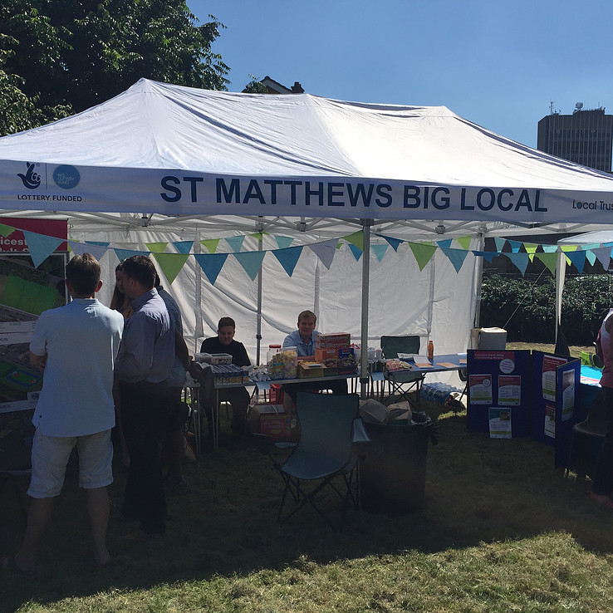

As promised in our first Big Local Plan, consultations were a big part of St Matthews over recent years. It meant SMBL was regularly listening to the views of residents, workers and visitors to St Matthews and that they were taken into account when making decisions which have the potential to affect their interests.

Another comprehensive consultation programme was devised to revisit the original priorities and to establish the priorities for years 4 – 6. We needed to understand the community’s wishes and aspirations for their Estate with the support of further funding available from the Local Trust. A steering group was formed in December 2016, which was responsible for the consultation process required for the updated Big Local Plan. It comprised of a community development worker, two partnership board members and a Big Local representative. The steering group produced a consultation plan and regularly met to discuss the performance and progress, keeping up-to-date with the consultation plan (see Gantt chart – Appendix B).

## Consultation - Research methods

The priorities for the Big Local Plan 2017 were established through a number of consultation events across the Estate, targeting all age groups and the diversity of the residents (see Appendix B). This was only possible with the help and support of many partners and volunteers. For example, youth clubs were approached to consult young people, and elderly homes were visited to access seniors’ views. Institutions such as the Children, Young People and Families Centre (CYPFC) and Taylor Road Primary School provided valuable access to children and parents living in the area, especially during the school pick-up and drop-off hours. There was also an online survey available.

Data gathering was planned for two stages: phase 1 and phase 2. The former involved asking residents three broad questions:

* What is good about St Matthews?
* What is bad about St Matthews?
* What would make your life better?

To increase uptake in the number of people taking part in the survey, various incentives were provided taking into consideration varying needs and expectations. For example, for children and young people, there were occasionally free slices of pizza available upon the completion of questionnaire, and all participants had the option of entering into a prize draw which involves a free trip to Skegness (which was already organised by SMBL). This resulted in 349 completed consultation slips.

The second phase of the survey was planned to re-consult with the community about the outcome of phase 1, i.e. what priorities emerged from the phase 1 consultation. It would be a repeat of the process carried out in phase 1. However, this time we also wanted to consult the local businesses, agencies and VCS organisations that were either based or worked on the Estate so the Big Local representative, Tim Morton, ran two focus groups that were well attended, with a total of 30 agencies attending. They were asked the same 3 questions, plus:

* What are your agency’s priorities?
* What can your organisation offer?

## Research findings

On analysing the responses from phase 1, it became clear that the key priorities that emerged were largely the same as the original ones and so we decided not to go ahead with the phase 2 consultation. Appendix C provides an analysis of the residents and agencies consultation responses. Below is a summary of the responses.

**What is good about St Matthews?**

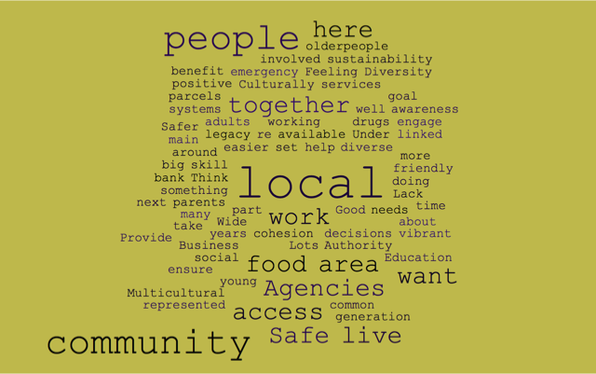The biggest positive response from both residents and agencies by far (45% and 35% respectively) was about the community – where everyone is appreciated, valued and respected. The Estate was seen as friendly, peaceful, diverse and where there is respect for different cultures and a vibrant, local community with good social cohesion. Agencies also felt that they worked together well with people with a wide skill set wanting to get involved. Residents and agencies also thought it was a safe area where people want to live.

**What is bad about St Matthews?**

By far the biggest concerns were around the Estate being cleaner and greener with residents identifying parking as the biggest issue (65%) followed by problems with litter and rubbish and the lack of greenery. These are long standing problems that cause residents continuing problems.

**What would make your life better?**

Following on from what is considered bad, residents clearly wanted to see something done about parking (55%), litter and rubbish (35%). Their priority was better facilities and activities for children and young people.

By contrast, the agencies responses were more focussed on the community – creating a positive impression, building confidence and providing a better quality of life and youth opportunities for residents. Something that also came up which wasn’t one of the original priorities was around improving health and well-being. They also wanted a space / community hub to operate from and where they could work in partnership to deliver a range of services and activities.

**What are your agency’s priorities?**

35% of agencies priorities highlighted a need to connect with and involve older people and a desire to develop an inter-dependant community. They want to continue to work in partnership to increase capacity and offer value for money. Funding for creative and youth projects and community cohesion were also mentioned.

**What can your organisation offer?**

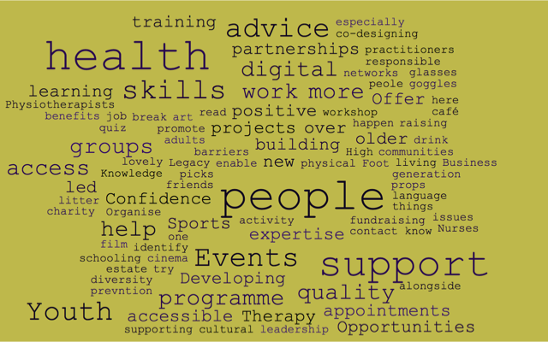It is apparent that there is a great willingness and commitment to work in partnership. 39% wanted to offer support utilising the broad range of skills and expertise that organisations can offer to support residents and deliver a range of activities and services in partnership with other organisations. The need to continue to develop relationships and work in partnership was very evident in many of the responses.

## Strengths and weaknesses of findings

One of the strengths of SMBL’s research was that a number of research methods were used to engage various social groups to get the most accurate results, and was therefore representative of the whole community. The questionnaire survey has allowed SMBL to gather information from a large audience in a relatively small geographic area, for a very low cost. Next to being inexpensive and flexible, questionnaire surveys were quick and easy to analyse since we did not need to wait for another company to deliver the answers.

A perceived weakness, given the results of the phase one consultation were similar to the previous results, could be that there is a lack of understanding of what the parameters of the funding are. We know from our data that things like health are a big issue on the Estate, but this is rarely mentioned. Could we have been clearer on what the funding can be used for? Is it a case of thinking we can only do what we’ve always done? Or that we aren’t able to supplement statutory services? These questions will need to be addressed at future consultations to ensure we are accurately capturing the needs of the community.

## Priorities: What the community wants

Given the results of the phase 1 consultation and the feedback from the Community Conference, the steering group agreed that the original vision and priorities should still stand and the revisited priorities should continue under the umbrella of our original vision. The Board then had a workshop where we looked at the consultation findings and agreed the priorities to be included in the plan. It was also agreed that we wanted to be able to become more reactive in the future, now that we are more established and there are going to be many new challenges and opportunities in years 4 – 6. The current political climate and the reduction in funding for statutory and voluntary sector services means that we may have many additional challenges that affect residents in the coming few years and we want to be able to be in a place to react to these challenges as necessary. We want to continue with the building of the MUGA as our main priority for year 4. Taking over the lease on St Matthews House will also provide us with an opportunity to develop the services we offer to the Estate and to look at how we can achieve long term sustainability through finding creative ways of generating income and sourcing additional funding.

**To make St Matthews a place which is cleaner and greener**

1. **Parking**

Amongst the most frequently occurring finding in the latest consultation was the parking issue in St Matthews, as many as 55% of residents mentioned parking as a concern either directly or indirectly.

Increasing numbers of homes have a car in St Matthews, and indeed some of these homes have more than one car. More cars but the same amount of room to park often causes friction in St Matthews. Since there is no off-road parking for the vast majority of houses in St Matthews, the problem is intensified.

In addition, due to the close proximity of St Matthews to the City Centre, the area has become a ‘free parking area’ for people who work in the City. Parking outside someone else’s home that is not yours has been found to cause a great deal of distress, especially when parking spaces are seriously limited.

The residents felt that the introduction of resident parking and increasing the number of parking spaces in the area would help alleviate the problems associated with parking.

1. **Environmental Appearance, Litter and Rubbish**

Another issue identified by the community was the community’s concern about the appearance of their area. Over a third (35%) felt that the community has a problem with the amount of litter and rubbish that is primarily on the streets and secondly in courtyards, and approximately 10% felt that the environmental appearance of the area was a concern.

The community thought that better maintenance of streets, courtyards and public roads would make St Matthews ‘cleaner’. It seems that litter and rubbish reduces and in some cases completely destroys the pride that residents have about living in St Matthews. It gives the look that the area is uncared for, not only impacting community spirit and people’s wellbeing but also it will discourage people from visiting the area. Although there is not enough evidence on this consultation, litter and rubbish are known to add to crime and anti-social behaviour.

The litter and rubbish problem also affects individuals’ health, i.e. an increase in litter leads to an increase in rats, mice and other infestation which creates a health hazard. People who live in areas with a litter problem are more likely to suffer from mental health problems.

The community felt that the following would be useful in alleviating the problem of litter and increasing visits to the area:

* Better maintenance of streets, courtyards and public roads
* Poster campaigns aimed at children and young people
* More bins installed in the community
* Maintenance of grass and trees in court yards and in public parks
* Improved appearance of shops

**Continuing priorities:**

* The car share scheme that has already been set up
* An annual community clean-up day
* The gardening / grow your own / composting project and to invest in tools and resources to enable this to develop into a long running project

**New priorities:**

* To set up a St Matthews Cycling Club
* To develop a local bike hire scheme

**To make St Matthews a place where everyone is appreciated, valued and respected**

1. **Better facilities for children and young people**

30% of respondents wanted better facilities for Children and Young People. Facilities like the Contact Project have closed and funding cuts have meant reduced services on offer. Some of the priorities mentioned were:

* Provide sports and educational activities
* More entertainment
* Better playground facilities
* Extend the opening hours of the Neighbourhood Centre

**Continuing priorities**

* The Community women’s café
* The development of the Community Hub
* The building of the MUGA

**New priorities**

* To set up of a Youth Panel so young people can decide what activities and services they would like
* To develop a programme of youth activities, particularly to address the lack of facilities and to tackle anti-social behavior

**To make St Matthews a place where everyone can reach their potential and local business flourish**

**Continuing priorities**

* Free Wi-Fi installed
* Strengthen and develop our partnerships with local businesses and agencies and establish what they can offer
* The grants programme
* Credit Union for residents
* Training courses and funding for training to include parenting and internet safety

**New priorities**

* To work with our health partners to develop health services and activities
* To establish a Youth Apprenticeship Scheme with local businesses
* To set up a resident discount scheme with the support of local businesses

**To make St Matthews a place where everyone feels safe and secure**

**Continuing priorities**

* Car safety events
* Cycle safety events and workshops annually

**New priorities**

* To commission a project that promotes a positive image of St Matthews to change people’s perception of the Estate and addresses the fear of crime

**To make St Matthews a place where we can celebrate diversity, talent and creativity**

1. **Multi-Use Games Area (MUGA)**

One of the most recurring findings of the survey for the Second Big Local Plan (2017) was the community’s wish for better facilities for children and young people. Community recreation centres can help benefit both the body and the mind. For example, people who exercise regularly have lower blood pressure, delayed onset of diabetes and lower stress levels (reference 11)

However, this is nothing new. Another consultation was carried out in 2016 to measure residents’ perception of the community, clearly indicating their wish for a MUGA. The results of the initial consultation will be used in this section due to the in-depth nature of the study. As briefly mentioned above, the results were largely in favour of the development of the MUGA. For example, out of the 357 people who participated in the study, 70.2% of residents felt that it was important to develop a sports pitch in St Matthews and 81.7% felt that an area for games should be developed for children.

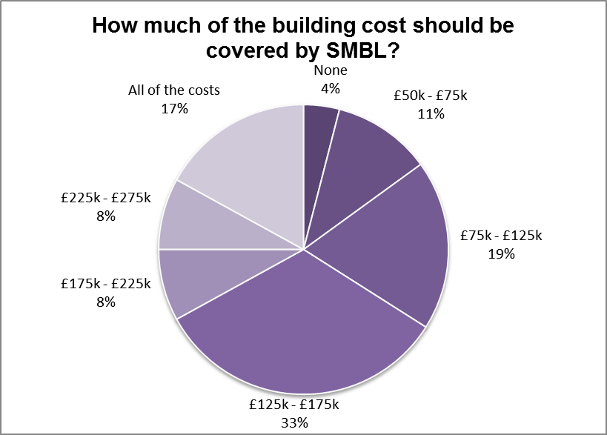Moving on, around £650,000 will be left for St Matthews for the remaining 7 years of the plan, and participants were asked how much of this money should be spent on the MUGA. Participants’ perceptions about the amount of financial support were mixed but there was wide support for some financial covering of the MUGA. For example, 33% felt that between £125 - £175k should be spent on the MUGA, followed by 19% who said between £75-£125k, and only 4% felt that no money should be spent on the MUGA. Put more simply, 66.1% felt that at least £125k should be contributed by SMBL (see chart).

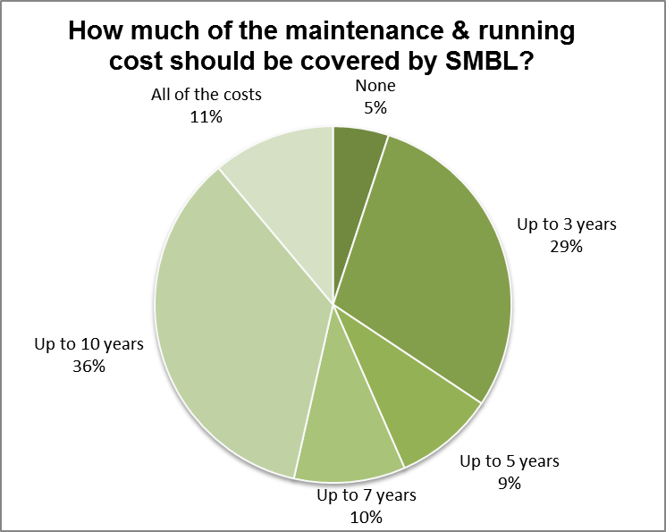There will inevitably be maintenance costs, which need to be found. This maintenance cost is going to include things such as: repair, electricity, staffing etc. A total of 82 people answered this question, of which the majority have felt that some of the maintenance and running cost should be covered by SMBL (95.1%) - see the chart. Of these participants, 56.1% felt that at least £42k should be provided, and 11% felt all of the maintenance and running cost should be covered by SMBL. In contrast to this finding, only 4.9% felt that none of the cost should be contributed from the SMBL fund.

When the participants were asked if there are any other activities that they would like to see, numerous suggestions were made. These suggestions were commonly badminton court, cricket court and gym.

To date, the following has been done in relation to developing a MUGA in St Matthews.

* The working group was set in the late 2015, comprising of local residents and organisations.
* The first meetings discussed the community’s demand for a MUGA in St Matthews, which became evident through public consultation.
* The working group made initial enquiries to Leicester City Council about the proposed location, with no major objections being identified by the planning department for turning the land into a MUGA site. Negotiations for the lease of the land are still ongoing.
* The working group carried out site visits to MUGAs across Leicester in an effort to understand the pros and cons of each design. A representative was available to brief the working group.
* The working group decided on an ideal MUGA design, bearing similarities to the Braunstone Grove in Leicester.
* The working group communicated with a building contractor (DURA Sports) about the development of a MUGA in St Matthews, to get a better idea of cost, design and maintenance.
* The working group appointed a Project Manager for this task.
* Local community organisations were approached in regards to funding. Taylor Road Primary School did consider contributing but they have now decided they are unable to.
* National and International organisations were approached for funding. Cruyff Foundation interested in contributing some funds (£50k), only if their specifications are met. In addition to the Cruyff Foundation, Samworth Brothers (£40k) and Sports England (£100k) have been approached for funding. Negotiations are pending with the former, and the outcome of application is pending with the latter - Sports England. If we are successful with the additional funding applications the financial contribution from SMBL will be reduced.

The Board agreed that the funding and building of the MUGA will be the main financial priority for Year 4. See Appendix D for the MUGA Business Case.

**Continuing priorities**

* Support for Parks Day

**New priorities**

* To use the MUGA to hold 2018 World Cup and 2020 World Cup / Olympics events
* To hold an annual community celebration / big lunch

## What we want to achieve – Table of year 4 – 6 priorities

|  |  |  |  |  |  |
| --- | --- | --- | --- | --- | --- |
| ***We want St Matthews to be a place which is cleaner and greener. (environment & open space)*** | | | ***Year &***  ***proposed budget £*** | | |
| ***Outcomes (what we will achieve...)*** | ***Priorities and Objectives***  ***(What we will do...)*** | ***Action***  ***(How and when will we achieve it...)*** | ***4*** | ***5*** | ***6*** |
| *We want to:*  *encourage responsible behaviour on the street and at home encourage energy efficiency encourage walking, cycling and bus use encourage garden improvement and grow your own* | *Address the parking issues in St Matthews* | *We will continue to lobby the Local Authority and work with St Matthews Tenants and Residents Association to put pressure on them to take some action to address the situation.* | *Nil* | *Nil* |  |
| *Improve environmental appearance, litter and rubbish* | *We will continue to lobby the Local Authority Housing Department and work with St Matthews Tenants and Residents Association to put pressure on them to take some action to address the situation.* | *Nil* | *Nil* | *Nil* |
| *Continue the car share scheme that has already been set up* | *We will continue to develop the car share scheme with funding for year 4 only* | *500* | *Nil* | *Nil* |
| *Continue with an annual community clean-up day* | *We will continue to fund and organise an annual community clean-up day* | *500* | *500* | *500* |
| *Continue to develop a gardening / grow your own / composting project and to invest in tools and resources to enable this to develop into a long running sustainable project* | *We will organise grow your own events, set up gardening and composting schemes, plant flower beds and hanging baskets. We will fund the tools and resources needed to enable this to happen* | *5000* | *1500* | *500* |
| *Set up a St Matthews Cycling Club* | *We will get volunteers to set up a cycling club in St Matthews and run regular events* | *Nil* |  |  |
| *To develop a local bike hire scheme* | *We will fund the purchase of bikes and equipment for a bike hire scheme* |  |  | *2000* |

|  |  |  |  |  |  |
| --- | --- | --- | --- | --- | --- |
| ***We want St Matthews to be a place where everyone is appreciated, valued & respected (young people, children, families & elderly)*** | | | ***Year &***  ***proposed budget £*** | | |
| ***Outcomes (what we will achieve...)*** | ***Priorities and Objectives (what we will do...)*** | ***Action (How and when will we achieve it...)*** | ***4*** | ***5*** | ***6*** |
| *We want to:*  *provide positive activities for young people, promote storytelling – our stories, St Matthews story, encourage inter-generational learning, encourage gatherings for courtyards and close neighbours, develop a winter care scheme for elderly and housebound residents, subsidise events and outings for all groups, develop support for groups of isolated people, be a source of information for everyone* | *Continue to provide better facilities for our Children and Young People* | *We will continue with the MUGA project and the development of the Community Hub and we will provide youth activities and set up a youth panel (see below)* | *Nil* | *Nil* | *Nil* |
| *Continue to run the Community Women’s café* | *We will continue to run the Community Women’s café weekly, supported by the local Police on the Estate and we will develop volunteers to carry it forward* | *500* | *500* | *500* |
| *Continue to develop the Community Hub* | *We will develop a range of services and activities to be delivered from the Hub and put together a business plan focussing on income generation* | *500* | *500* | *500* |
| *Continue with the building of the MUGA* | *The MUGA project will be a key priority for Year 4 – see separate section on details of funding and costs* | *n/a* | *n/a* | *n/a* |
| *Set up a Youth Panel* | *A Youth Panel will be set up with the support of local youth workers so young people can decide what activities and services they would like* | *Nil* |  |  |
| *Develop a programme of youth activities* | *A programme of varied activities, decided by the Youth Panel, will be delivered with a particular emphasis on addressing the lack of facilities and tackling anti-social behavior* | *1,000* | *2,000* | *2,000* |

|  |  |  |  |  |  |
| --- | --- | --- | --- | --- | --- |
| ***We want St Matthews to be a place where everyone can reach their potential & local businesses flourish (employment, enterprise & training)*** | | | ***Year &***  ***proposed budget £*** | | |
| ***Outcomes (what will we achieve...)*** | ***Priorities and Objectives (what we will do...)*** | ***Action (How and when will we achieve it...)*** | ***4*** | ***5*** | ***6*** |
| *We want to:*  *produce a directory of local businesses, run employability workshops for young people, develop employment advice and support, provide loans for local businesses to employ local people, encourage appropriate business/ social enterprise development, commission support for local businesses in danger of failure,*  *encourage mutual support among local business* | *Continue to campaign for free Wi-Fi to be installed* | *We will continue to lobby the Local Authority to have free Wi-Fi installed on the Estate for residents and businesses* | *Nil* | *Nil* | *Nil* |
| *Strengthen and develop our partnerships with local businesses and agencies* | *We will continue to strengthen and develop our partnerships with local businesses and agencies and establish the support they can offer and what projects we can work on together* | *Nil* | *Nil* | *Nil* |
| *Continue with the small grants programme* | *We will continue to offer a small grants programme for residents and VCS organisations to bid for funding for projects that meet our criteria and vision priorities* | *10,000* | *10,000* | *10,000* |
| *Continue to offer a Credit Union for residents* | *A Credit Union service will continue to be offered to residents with sessions held at the Community Hub. We will offer financial incentives for residents to join and save regularly* | *2,000* | *2,000* | *2,000* |
| *Continue with funding access to training* | *We will continue to fund access to training for individuals and commission and fund courses that support our vision and priorities (to include parenting and internet safety)* | *4,000* | *4,000* | *4,000* |
| *Work with our health partners to develop health services and activities* | *We will work to develop and strengthen our partnerships with health agencies to support them to deliver targeted services and activities on the Estate to address the health needs of the community* | *Nil* | *Nil* | *Nil* |
| *Establish a Youth Apprenticeship Scheme with local businesses* | *We will set up and fund a youth apprenticeship scheme, working with local businesses and offering a financial incentive for them to take a young resident as an apprentice* | *2,000* | *2,000* | *2,000* |
| *Set up a resident discount scheme with the support of local businesses* | *We will work with local businesses to set up a resident discount / loyalty scheme that offers a percentage discount on purchases* | *500* | *500* | *500* |

|  |  |  |  |  |  |
| --- | --- | --- | --- | --- | --- |
| ***We want St Matthews to be a place where everyone feels safe and secure (safety & security)*** | | | ***Year &***  ***proposed budget £*** | | |
| ***Outcomes (what will we achieve...)*** | ***Priorities and Objectives (what we will do...)*** | ***Action (How and when will we achieve it...)*** | ***4*** | ***5*** | ***6*** |
| *We want to:*  *improve environmental safety, improve relationship with police and council workers, educate people about staying safe, provide funding to encourage activities as alternatives to anti-social behaviour, support safety campaigning, take crime reduction measures* | *Continue to hold car safety events* | *We will continue to support and work with our local police to hold regular car safety events* | *Nil* | *Nil* | *Nil* |
| *Continue to put on cycle safety events and workshops annually* | *We will continue to hold an annual cycle safety event and workshop, providing free safety equipment* | *1,000* | *1,000* | *1,000* |
| *Commission a project that promotes a positive image of St Matthews* | *We will commission a project that promotes a positive image of St Matthews to change people’s perception of the Estate and addresses the fear of crime* | *1,500* |  |  |
| *Fund any activities / events / resources that may be needed as a reaction to any future safety concerns* | *We understand that we may need to react to situations that threaten the safety and security of residents, so we will use additional funding for any activities, events and / or resources that may be required* | *1,000* | *1,000* | *1,000* |

|  |  |  |  |  |  |
| --- | --- | --- | --- | --- | --- |
| ***We want St Matthews to be a place where we celebrate diversity, talents and creativity (culture and leisure)*** | | | ***Year &***  ***proposed budget £*** | | |
| ***Outcomes (what will we achieve...)*** | ***Priorities and Objectives (what we will do...)*** | ***Action (How and when will we achieve it...)*** | ***4*** | ***5*** | ***6*** |
| *We want to:  encourage health lifestyles, improve sports provision & access, support annual St Matthews Community Parks Day, run local cultural festivals, produce a directory of local facilities & agencies, provide opportunities for creativity* | *Support for the annual Parks Day* | *We will continue to fund, provide resources for and support the annual Parks Day* | *2,000* | *2,000* | *2,000* |
| *We will use the MUGA to hold an annual event* | *We will use the MUGA to hold an annual event focused on sport and health, including the 2018 World Cup and the 2020 World Cup / Olympics* | *1,000* | *1,000* | *1,000* |
| *Hold an annual community celebration / big lunch* | *We will hold an annual community event / big lunch that celebrates community cohesion and diversity* | *500* | *500* | *500* |
| *Support for other festivals and events as they arise* | *We understand that we may need to fund activities, events and / or purchase resources that may be required to support celebrations to promote community cohesion and increase access to cultural events* | *1,000* | *1,000* | *1,000* |

# Method of Delivery – How we will deliver demand

Key to the success of SMBL and our ability to achieve our agreed priorities for the coming 3 years is how we will deliver, how we will continue to inform, engage with and involve the community and our partners to create a feeling of ownership. It is also crucial to look at the long term legacy and sustainability of SMBL.

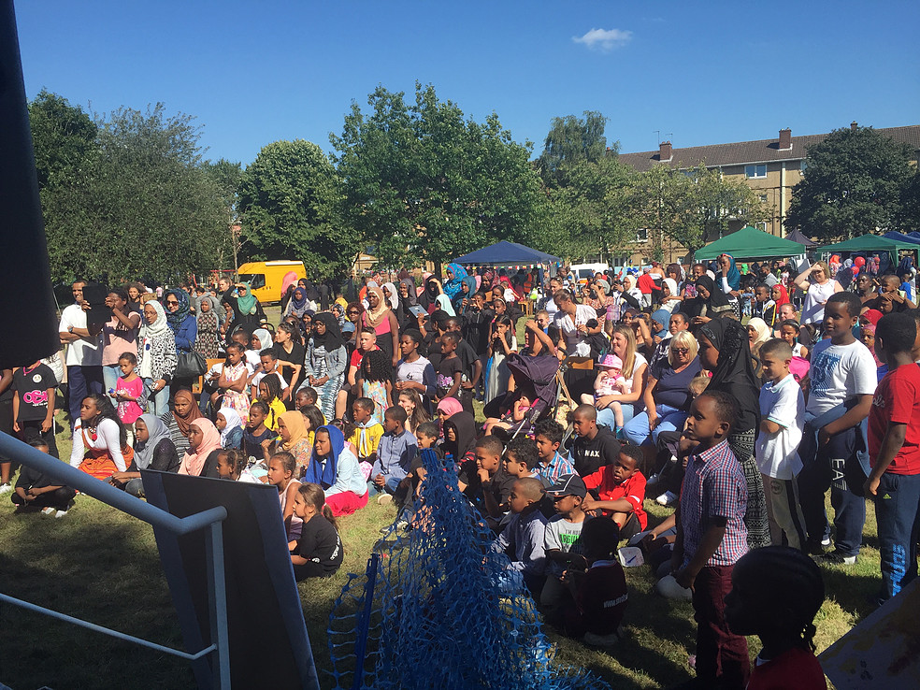

## Communication plan

In order to inform residents and other interested parties of what we are doing we will continue our social media presence, and hold a range of open events. We will relaunch the newsletter and revamp the website. We will continue to send out regular emails about what’s going on. We will continue to consult with the community via trips, community and celebration events, and a range of activities.

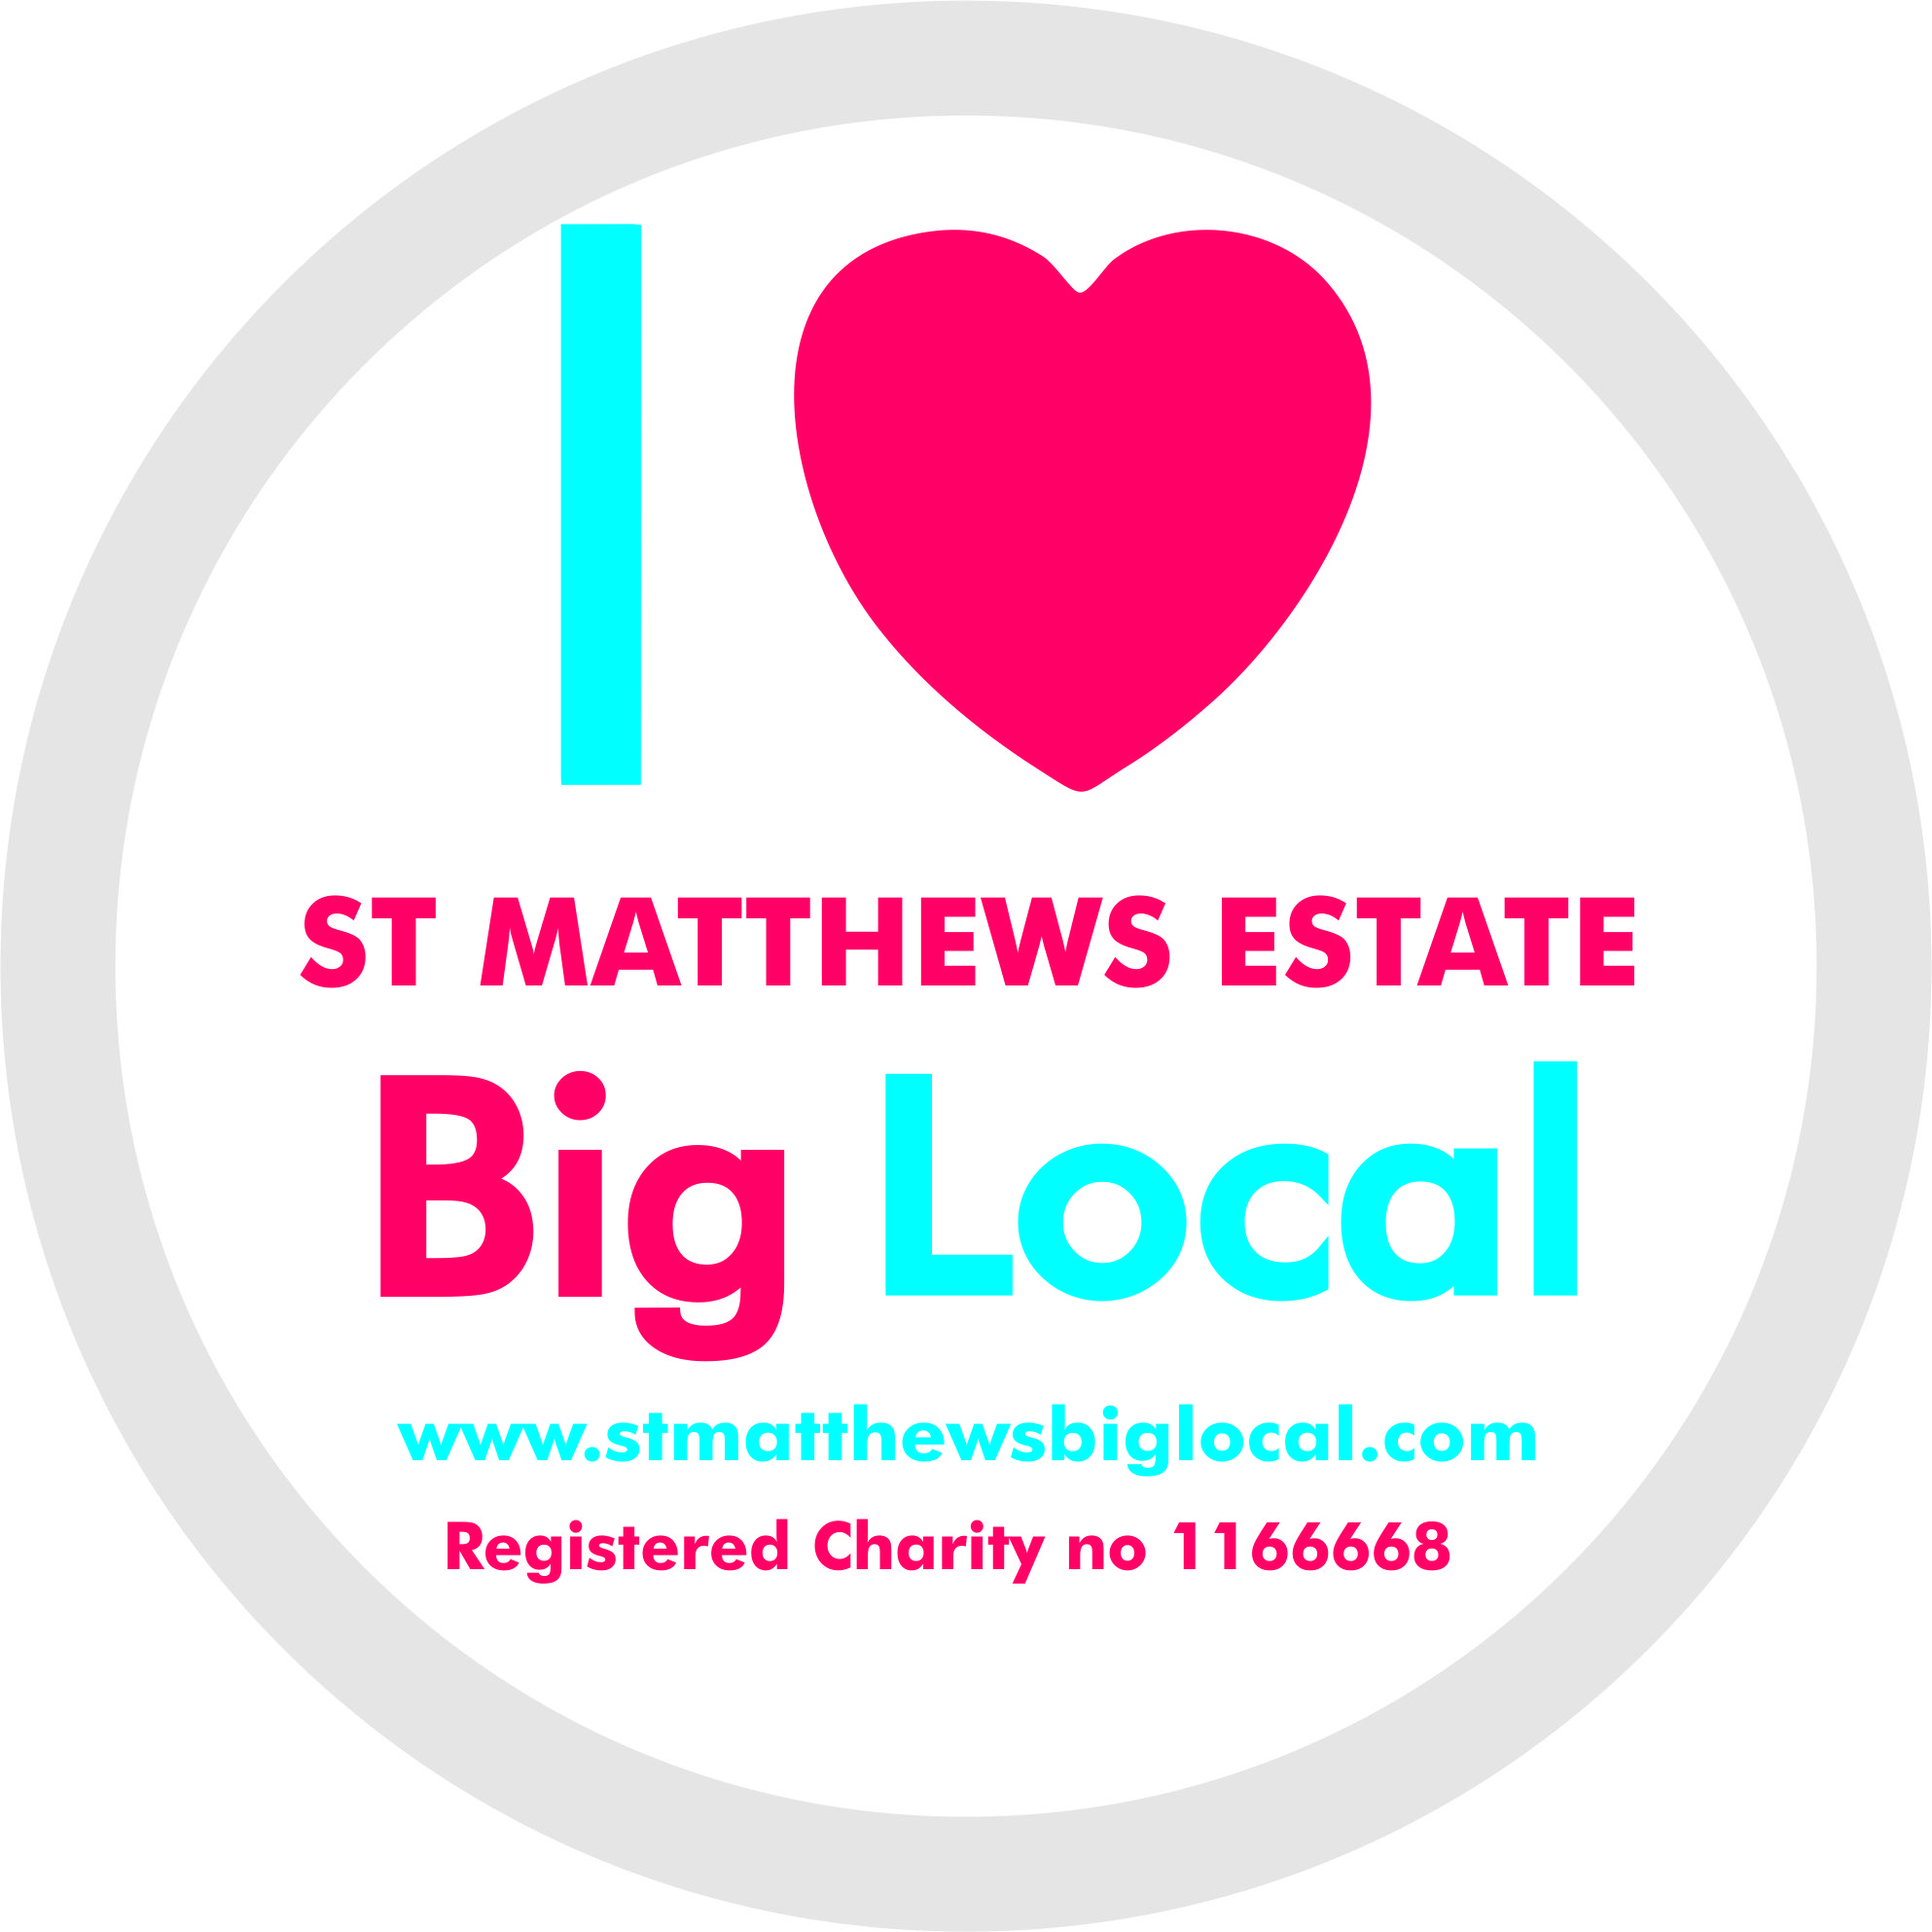We have a large communication reach within the community. Leaflets and newsletter are delivered to each of the 2000+ homes on the Estate via a partnership with the local petrol station who deliver

frequent flyers locally. Our text message service can send out an instant message to over 300 residents and 100 local agencies. We have an email distribution list of 500 people - we use Mailchimp to support the administration of emails so we can monitor emails that are read and it allows people to unsubscribe if they don’t find our information useful. Our social media followers, particularly Facebook, help to reach the audience demographic we aim to reach, and is followed by 400 people. We have 758 followers on Twitter and a massive reach, for example our social media posts for just 16 days in May reached a potential audience of 22.6k people.

## Partnership working

There is a vast range of skills, expertise, services and opportunities that our partners can offer. We will continue to work with and strengthen our existing partnerships and develop new ones. It has been encouraging that so many organisations and agencies are keen to work with us so we need to focus on embedding the links we already have and establishing new ones. We need to think strategically about how we can look to develop joint funded and match funded activities and services and even explore opportunities for pooling of resources and funding.

The partners we currently work with and/or who attended our Community Conference are listed in Appendix E.

## Staff / Volunteering

We will endeavour to find additional funding for staffing the Community Hub and to recruit more volunteers to support the delivery of the priorities. We are currently awaiting a decision on an application to the Tudor Trust (£40k) that, if successful, will be used to pay for staff to deliver a range of services and activities. If not successful we will consider funding the staffing from our budget. The key tasks will be community development work, funding applications and generating income.

## Challenges and opportunities

The key challenge for years 4 – 6 is to build the MUGA and start to build up the usage by the community and to facilitate programmes of activities run by our partners. The long term goal will be to generate income from hiring the MUGA but we anticipate this to be a long term aim.

Another challenge for SMBL and the community will be any potential further funding cuts and closures of any voluntary, community sector organisations and how, if at all, we are able to respond to the changing needs of the Estate and its residents.

An ongoing issue is around getting more residents and community groups to be more proactively involved in the running of SMBL rather than just benefit from the services and activities. We will focus on community development work to encourage the community to take ownership of SMBL.

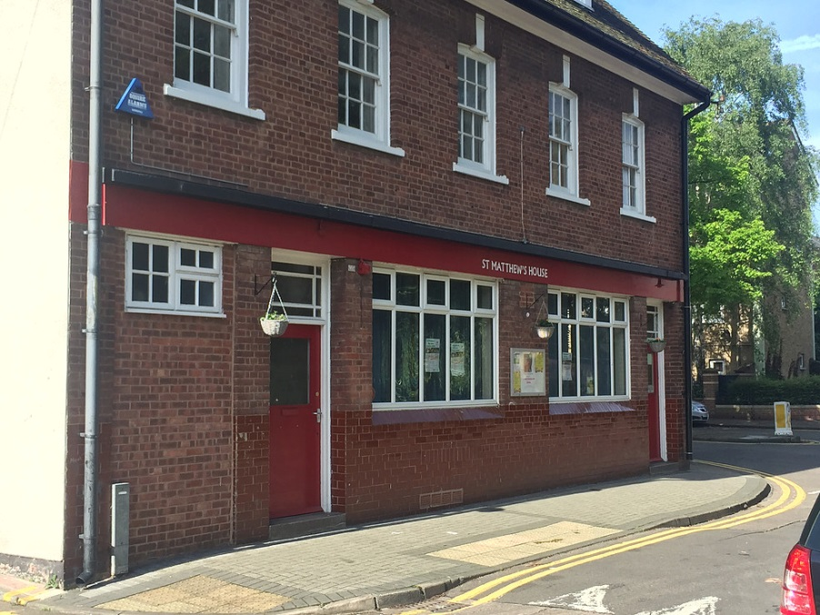Our biggest opportunity is to develop St Matthews House as a community hub. We know from our consultations that people recognise St Matthews as a vibrant, diverse, friendly, multi-cultural community. We need to recognise this and provide a central space that offers the community a range of services and activities and brings the community together. The Hub can provide so many opportunities e.g. training, a food bank, credit union, advice sessions, celebrations, community café, lunch clubs, and a meeting space. We hope that the Hub will evolve over the next 3 years to become a focal point for the residents.

Finally, our greatest challenge and opportunity in the coming years is to develop a sound business model so that we can generate income (via various creative methods) that will support the sustainability and legacy of SMBL beyond the initial 10 years and enable us to continue to meet the needs of the community.

# Plan review

The SMBL partnership reviewed the first Big Local Plan in 2015 (YR1) and 2016 (YR2) and this new three year plan also forms part of our plan refresh for this year (2017).

It is the intention of the SMBL Partnership to compete one plan review during the delivery of this new plan. The review will take place in the autumn of 2019 and will include a review for 2016/17 (YR3), 2017/18 (YR4), 2018/19 (YR5).

# Expenditure – How much we need (table of expected expenditure)



# References

1. <http://dclgapps.communities.gov.uk/imd/idmap.html>
2. http://localtrust.org.uk/assets/downloads/plans/St%20Matthews%20Big%20Local%20plan.pdf
3. <http://www.economist.com/news/britain/21641283-unnervingly-poor-children-seem-fare-better-poor-neighbourhoods-paradox-ghetto>
4. <http://www.taylorroadprimary.co.uk/attendance-data/>
5. <https://www.gov.uk/government/organisations/ofsted>
6. <https://www.police.uk/leicestershire/NE16/crime/+iTfHDJ/stats/>
7. https://www.gov.uk/government/news/tell-us-what-you-think-about-reforming-the-police
8. Reith: 156 ‘A new study of police history’ Oliver and Boyd
9. <https://leics.police.uk/news-appeals/news/2017/04/24/popular-officer-receives-bem-for-services-to-policing>
10. <https://www.stmatthewsbiglocal.com/documents>
11. <http://www.sportadvisory.com/blog/2016/07/15/11-benefits-of-a-community-recreation-center/>

# Appendices

Appendices A – E below are attached as separate hard copy / electronic files

1. **SMBL Constitution**
2. **GANTT Chart**
3. **Consultation analysis**
4. **MUGA Business case**
5. **Table of local / partner organisations**

All additional documents and policies including those listed below can be accessed and downloaded from the St Matthews Big Local website: <https://www.stmatthewsbiglocal.com>

**Partnership Trustees Application Form**

**Partnership Memorandum of Understanding**

**Partnership Code of Conduct**

**Partnership Members**

**Grant Application Form**

**Room hire agreement**