**St Matthews Multi Use Games Area (MUGA) at Dysart Way and Willow Street, Leicester**

**20171738**

**Travel Plan and Parking Management Strategy**



|  |
| --- |
| Simon Johnson  Travel Plan Coordinator  St Matthews MUGA  January 10, 2018 |

**Table of Contents**

1. **Introduction**
   1. Background
   2. Travel Plan Requirements
   3. MUGA Site
   4. MUGA Uses
   5. Car Parking Availability
   6. Parking enforcement
2. **Objectives**
3. **MUGA Management Actions**
4. **Monitoring and Targets**
   1. Monitoring
   2. Targets
5. **Conclusion**

Issued by: _____________________________________

Approved by: __________________________________

Date: _________________________________________

**1.0 Introduction, Accessibility and Parking Management**

1.1 Background

In February 2012 St Matthews was declared a Big Local Area by the National Lottery and awarded £1 million to use over 10 years to deliver a plan developed by a resident led partnership. <https://www.stmatthewsbiglocal.com/the-neighbourhood-plan>. The ten years started once the Big Local Plan had been accepted by Local Trust, in August 2104. The consultation that helped to create the plan identified once again a need for better access to community facilities and the need for a MUGA.

Most of the homes in the area are flats and although the courtyards are substantial, the playing of football and other games tends to lead to complaints by neighbours of Anti-Social Behaviour. There are several small play areas along what is known as the Spine, but these are limited to smaller children’s needs and only children in the relevant block can access them.

A recent national study showed evidence of strong links between childhood obesity and levels of deprivation <http://indicesofdeprivation.co.uk/2015/08/12/child-obesity/>

The St Matthews Centre has a large Sports Hall, however the cost of hire and availability is an issue for residents. In terms of organised youth provision –The What Cabin on Willow Street and the LCC Youth Service continues to offer limited activities.

A partnership funded by St Matthews Big Local and Leicestershire Police with LCFC Community Trust delivers sports activities for young people in the area.

We have a commitment from our partners LCFC Community Trust to provide structured sports development sessions daily, employing local young people who have been trained by the club.

The MUGA has a number of objectives:

* To provide an outdoor (multi) sports facility for the use of the residents of St Matthews, who currently have very limited access to sports facilities in the area.
* The proposed facility, which comprises of a Cryuff Court 3G playing area, a multi-purpose court for basketball, Netball & Tennis and a jogging track.
* To provide a safe environment to play sports outdoors for the community.
* To bring the community together through sports activities, encouraging engagement and interaction with diverse communities.
* To provide through our partners LCFC Community Trust structured sports development sessions daily, employing local young people who have been trained by the club.
* The MUGA will attract different groups of users not just football.
* To provide a home for training for two long standing football clubs in St Matthews – Iqra FC and St Matthews Dynamos, (who have never been able to train or play at “home”).
* To deliver on Sport England’s objectives of increasing the regular and sustained participation by people in sport, and for it to become a habit for life.

The MUGA will be owned by St Matthews Big Local, which will have a 25 year peppercorn lease with Leicester City Council for the land between Dysart Way and Willow Street.

The St Matthews Big Local, Board of Trustees is made up of residents of St Matthews and local workers

1.2 Travel Plan Requirements

An overarching Travel Plan and Parking Management Strategy (TP & PMS) has been undertaken as per the planning requirement covering all the uses at the MUGA. The content of this agreed version of the TP & PMS was undertaken after discussions and meetings between **Tom Ipgrave** (LCC), **Bal Minhas** (Leicester City Council’s Travel Plan Officer and **Naim Razak** (St Matthews Big Local). All the requirements needed to be covered with regards to the Travel Plan condition have been agreed and covered in this TP & PMS.

The primary aim of developing the MUGA is to provide a modern, state of the art sporting facility for the residents of St Matthews. However we envisage there will be some users of the facility from neighbouring areas of the city. Therefore the aims of the TP & PMS include helping raise the awareness of responsible parking management and making all attendees aware of the sustainable travel alternatives travelling to the MUGA.

**St Matthews Big Local is committed to informing all attendees of the MUGA of the options available to all users including: promoting sustainable journey planners, raising the awareness of the cost and environment benefits of car sharing, as well as, encouraging responsible parking on and off site and discouraging irresponsible and illegal parking on and off site.**

Bal Minhas will be kept informed of any changes to the uses of the MUGA at all times.

National Planning Policy Framework (NPPF)

The requirement of developments to undertake Travel Plans/Transport Assessment is needed as part of the government’s guidelines to help achieve and generate sustainable developments. Transport is one of the major elements to review when facilitating overarching sustainable developments. Local Authorities set thresholds for developments. Developments seeking planning permission in Leicester with gross floor areas over 1000m² will require to undertake a Travel Plan that has to be completed and agreed prior to occupation of the site.

The following are the relevant extracts from the NPPF pertinent to this development.

*29. Transport policies have an important role to play in facilitating sustainable development but also in contributing to wider sustainability and health objectives. The transport system needs to be balanced in favour of sustainable transport modes, giving people a real choice about how they travel.*

*34. Plans and decisions should ensure developments that generate significant movement are located where the need to travel will be minimised and the use of sustainable transport modes can be maximised.*

*36. A key tool to facilitate this will be a Travel Plan. All developments which generate significant amounts of movement should be required to provide a Travel Plan.*

* 1. MUGA Site and Location

The MUGA is located on the land between Dysart Way and Willow Street in St Matthews area. Willow Street is a residential street and Dysart Way forms part of the inner ring road. The site also is home to an outdoor gym and a small nature trail.

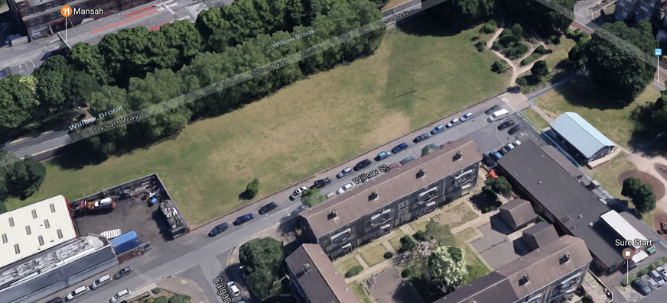The Muga site can be accessed from Willow Street which is a cul-de-sac, via Calgary Road or Wanlip Street.

The MUGA is easily accessed by public transport, with the number 21 First bus going through St Matthews every 15 minutes till 7.00pm. Furthermore both Arriva and First Bus have buses regularly going up and down Belgrave Gate, which is less than 5 minutes away from where the MUGA is located.

MUGA Uses

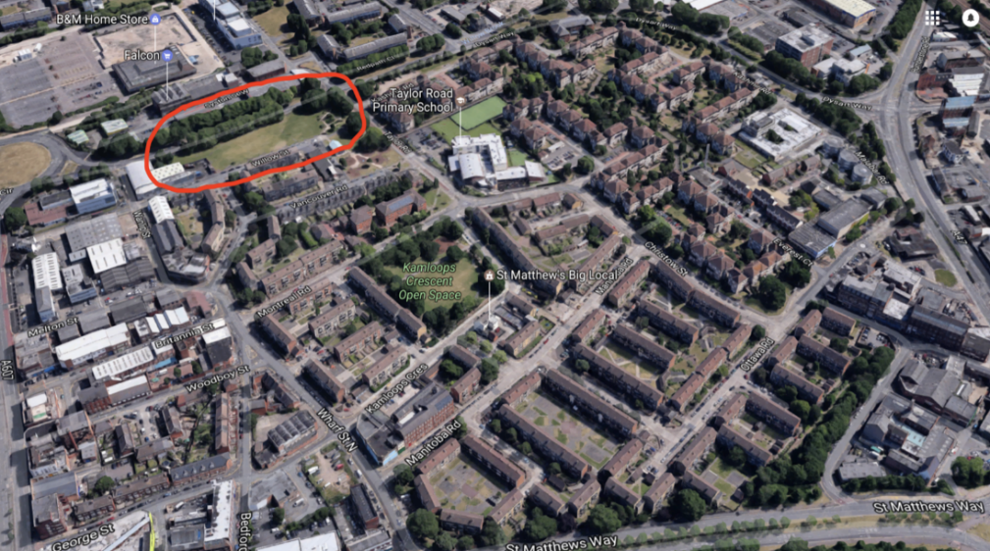A significant number of the users of the MUGA will be local residents of St Matthews, arriving by foot from within the area.

The MUGA is anticipated to have between 10 and 30 users participating in sports activities normally at any one given time.

It is expected that there will be approximately 4 big events promoting the MUGA and its facilities in a calendar year. The events will be mainly community tournaments aimed at bringing local residents together. It is anticipated that for these events there will be between 100 to 200 users. Again a significant number of these users will be local and therefore will be arriving by foot.

It is anticipated that, to generate income as part of the future sustainability strategy, the MUGA courts will be hired out to other users from neighbouring areas.

The availability of street parking can be limited during working hours from Monday to Friday due to commuters working in the city centre parking around St Matthews and then walking into the city centre.

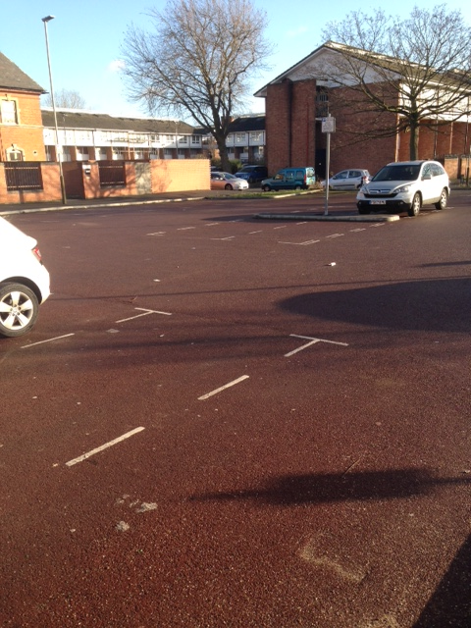It is noteworthy the hiring of the MUGA to outside groups/users are expected to take place mainly in the evenings when there will be street parking available.

Photographic evidence of parking in and around the immediate MUGA (appendix 1) was requested by Bal Minhas and was subsequently provided to him.

The evidence clearly highlighted adequate parking availability in St Matthews and the surrounding areas during expected times of events, along with public highway parking available on Orchardson Avenue including the ‘free to use’ parking spaces adjacent to the former Sainsbury site and the parking spaces available on the recently created car park on Belgrave Gate.

The details have been discussed and agreed with Bal Minhas with respect to parking provision and associated management of such other events.

Opening Times

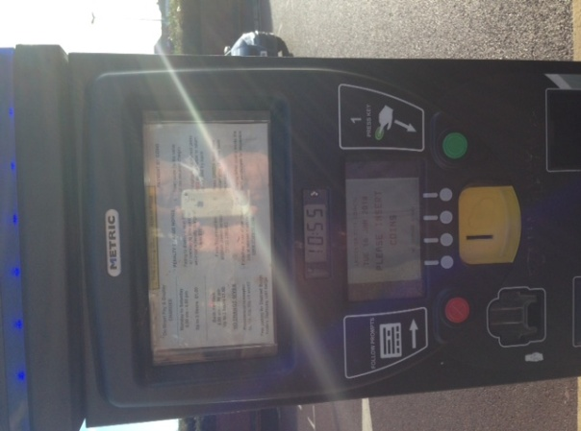The MUGA is anticipated to open 364 days a year; during term time the opening hours will be from **4pm** **to 10pm daily**, and the hours extended from **9am to 10pm** during the school holidays.

The TP & PMS has been developed and agreed recognizing these key facts.

* 1. Car Parking Availability

As well as the street parking in St Matthews, the following parking will also be available;

* The public highway parking available (up to 12 car parking spaces) on Orchardson Avenue.

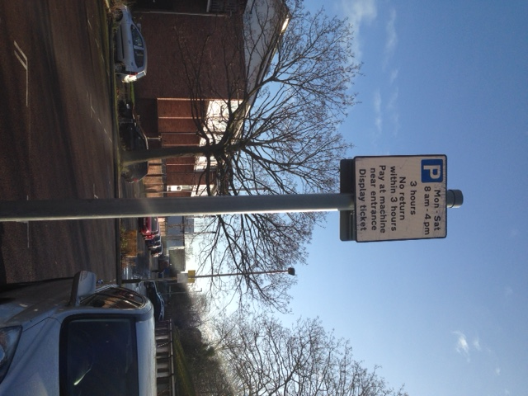

* Across Belgrave Circle, in front of what used to be the old Sainsbury’s (before it was relocated further up Melton Road), the City Council has provided circa 40 car parking spaces available for general usage
* The ‘free to use’ parking spaces on Belgrave Gate adjacent to the former Sainsbury site can accommodate up to 30 car parking spaces.

The MUGA will promote the availability of these car parking spaces in the area through publicising the following website:

1. <http://www.leicester.gov.uk/transport-and-streets/parking-in-leicester/where-to-park>

A **map identifying the car parks** will also be included as part of the ‘**How to get to the St Matthews MUGA**’ webpage.

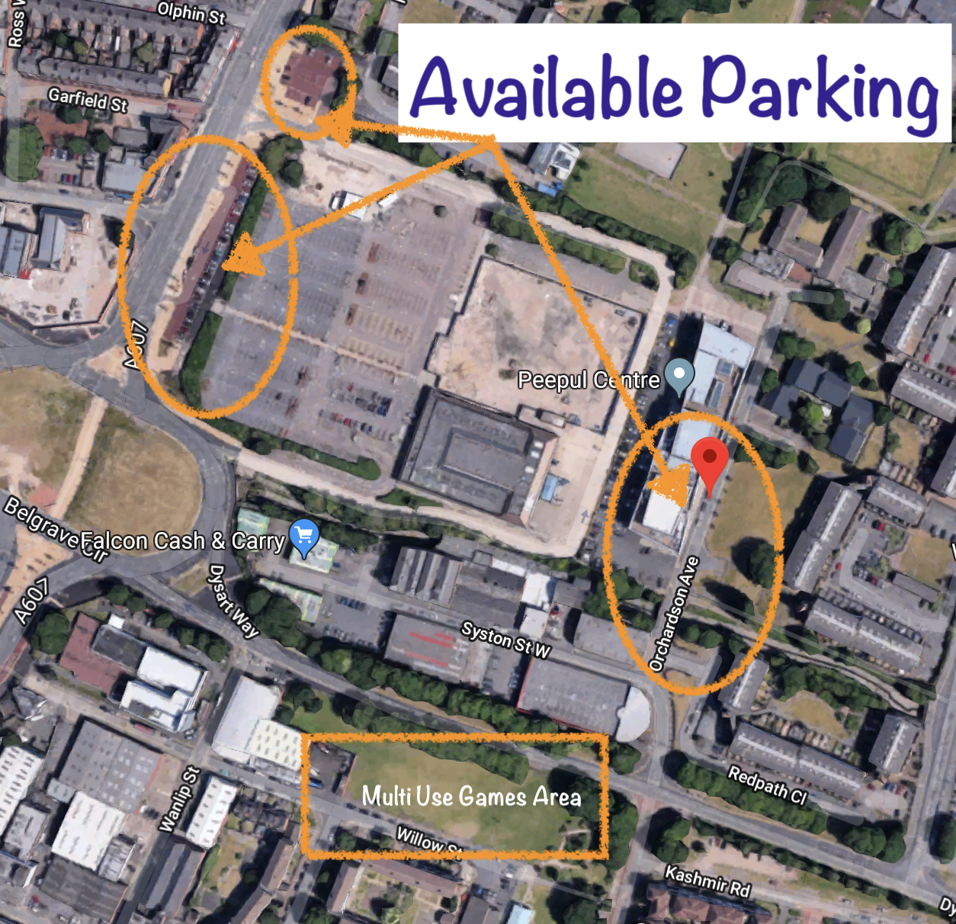

1.8 Parking Enforcement in the Immediate Area

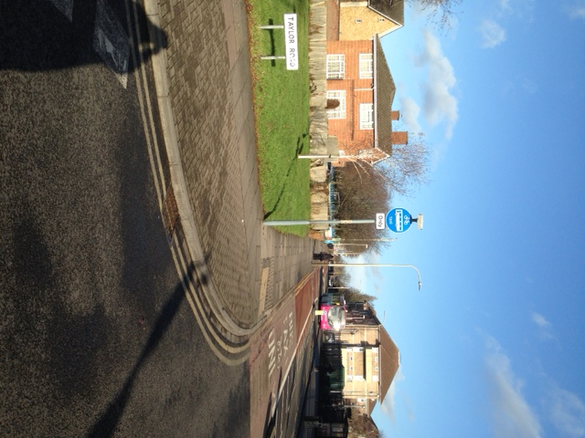

The immediate areas of the MUGA around Willow Street and Taylor Road, have parking restriction. It will be made clear on the website that these areas will not be parked on during at any time, with a very strong likelihood of fines to be paid if such action is undertaken. The area is heavily patrolled by LCC enforcement officers who act immediately on any transgressions committed.

**2.0 Aims and Objectives of the Travel Plan**

The main o*bjectives and aims* of the TP & PMS are as follows:

|  |
| --- |
| * To **reduce the vehicle usage** and encourage the take up of sustainable transport choices (particularly public transport and/or walking), by all users of the MUGA, where it is practical to do so. * Ensure **all users** are fully informed and aware of: the **recommended parking management strategy**, how to **plan a journey to the MUGA** * To maintain **up-to-date information for users** on evolving sustainable transport choices through links on the website and via mobile devices. * Encourage a strategy to **minimize traffic disruption** and **adverse parking impacts** in the local area through smart information systems. * Discourage any potential **irresponsible or illegal** on and off site parking by users. * To minimize inconvenience for MUGA users by **providing the most effective car parking options available** to them covering all arterial routes into the immediate area. * To maintain a **broad awareness** of MUGA users, and their evolving transport/ parking needs   + Work with LCC to provide a **safe access** to the MUGA for all attendees, and maximise safety operations * Undertake a yearly **Monitoring Report and meeting** with LCC’s Travel Plan Officer. |

It should be noted that the website, in particularly the ‘How to get to the MUGA’ webpage, will be the main focus of raising the awareness of the aims and objectives of the TP & PMS.

The existing website for St Matthews Big Local will include a webpage for the MUGA including a link, ‘How to get to the MUGA’. The webpage which will be the main way of informing attendees what is encouraged and discouraged in terms of travelling to the MUGA. Important announcements or initiatives/promotions will also be supplemented via the webpage.

The information expected to be included on the ‘**How to get to the site**’ webpage will include:

1. A map of the MUGA with regards to arterial links to the area.
2. A link to sustainable travel journey planners including:
3. **Choosehowyoumove** - <http://www.choosehowyoumove.co.uk/> . This weblink allows any walking, bus, cycle or car sharing journey to the MUGA to be planned including estimated journey times for each journey.

4. A short summary of what is encouraged and discouraged with regards to the parking management on and off site. A suggested summary would be along these lines:

**“St Matthews Big Local encourages all attendees to the MUGA to park responsibly and discourages irresponsible and illegal parking at all times. The Big Local strongly promotes, where practical to do so, sustainable travel modes (i.e. walking, or using the frequent bus services to St Matthews or nearby stops on Belgrave Gate) when travelling to the MUGA, particularly for journeys under 2km, in line with the stated aims and objectives of the St Matthews MUGA Travel Plan.”**

The St Matthews Big Local MUGA Travel Plan Coordinator

The Arena’s Travel Plan Coordinator (TPC) contact details are:

|  |
| --- |
| TPC: Simon Johnson  E-mail: [stmatthewsbiglocal@gmail.com](mailto:stmatthewsbiglocal@gmail.com)  Tel: 07446 864 116 |

The roles and responsibilities of the TPC will include:

1. Liaise with LCC’s Travel Plan Officer (TPO) to discuss any changes or issues affecting the Arena with regards to transport.
2. Undertake a Monitoring Report/meeting with LCC’s TPO yearly from the date of occupancy.
3. Update any information on the website or smart information systems.
4. Respond to any concerns or issues immediate neighbours may have (if indeed this is the case) with regards to any illegal or irresponsible parking by users of the Arena.

The list is not rigid, and just as the TP & PMS is an iterative process, so the roles and responsibilities of the TPC will match any issues or needs affecting the implementation of the aims and objectives of the TP & PMS.

**4.0 Monitoring and Targets**

4.1 Monitoring

Formal Monitoring of the Travel Plan will be undertaken 12 months after occupation and annually for a minimum of up to 5 years, and the Report presented to the St Matthews Big Local Board.

## The Monitoring Report will include a yearly MUGA attendee travel survey. These surveys will be an essential element of the Monitoring Report.

## The Monitoring Report will also include:

## A summary of any parking issues affecting the MUGA;

## Any travel issues affecting the MUGA;

## A summary of the monitoring results;

## Details of progress made since the submission of the previous reports;

## An assessment of whether the Travel Plan targets are on track to be met;

## An identification of actions and priorities for the forthcoming Travel Plan period

The end of year one Monitoring Report and subsequent Monitoring Reports will also be sent to Bal Minhas, Leicester City Council’s Travel Plan Officer (TPO). His details are:

|  |
| --- |
| LCC’s Travel Plan Officer: Bal Minhas  E-mail: [bal.minhas@leicester.gov.uk](mailto:bal.minhas@leicester.gov.uk)  Tel: 0116 4542849 |

**5.0 Conclusion**

This TP & PMS is a **live** document, which will be the overarching strategy the MUGA uses to raise the awareness and promote sustainable travel modes, in particular use of the bus services, ‘car sharing’ and responsible parking covering both on and off site (allowing effective access to the MUGA facilities), to all MUGA users. The intention of the initiatives is to help reduce single occupancy vehicle usage over the future years to the site by users where it is indeed practical to do so.

The TP &PMS implementation will be monitored by the St Matthews Big Local Board and be assessed by LCC’s TPO for the first 5 years starting from the first year after occupation in Summer 2018. A Monitoring Report will be prepared each year for the Board, which will include updates on the effectiveness of Travel Plan initiatives and their promotion, as well as, updates on any parking strategy issues.

**The St Matthews Big Local would like to thank Tom Ipgrave (Planner LCC) and Bal Minhas (LCC’s TPO) for all their help and guidance in setting out and identifying best practices with regards to the elements covered in this Travel Plan.**

**Public Transport**

(Contact Leicester City Council’s Public Transport Officer- Tel: 0116 4542832 for any information on current bus routes and proposed route changes in the future)

Free

Leicestershire Bus Map and Guide/timetables

Travel Line

Arriva Bus Timetables/discount info/leaflets

First Timetables/discount information/leaflets/Flexi Day info.

Hospital Hopper leaflets

**www.centrebus.co.uk**

**Cycling**

(Contact Leicester City Council’s Cycling Officer - Tel: 0116 4542873 regarding cycle routes from the development into the town centre)

You can also download a cycle map of Leicester or download from the map the area in and around the development via [www.sustrans.org](http://www.sustrans.org)

**Appendix 1**

**Photos of Calgary Street and Willow Street taken after 5pm.**

Calgary Street:

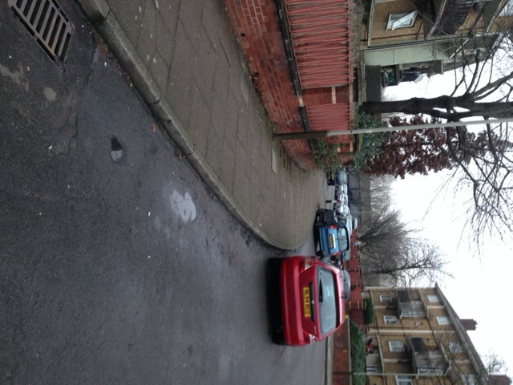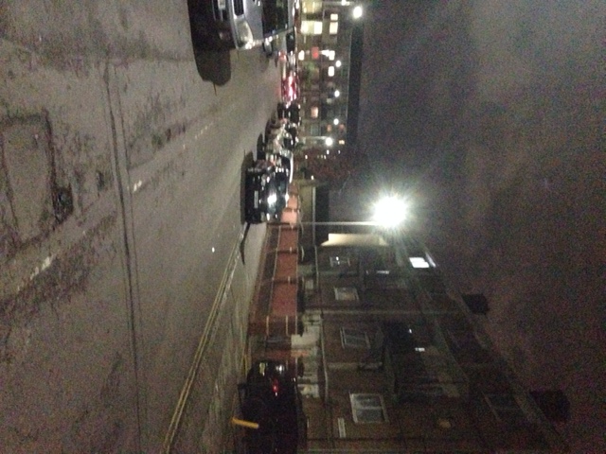

Willow Street:

